Contents
1 General 4
1.1 Introduction 4
1.2 Component environment 4
1.3 Use cases 5
1.3.1 Starting HW Resource Manager Server 7
1.3.2 Turning vibra on/off 7
1.3.3 Pulse the vibra motor 8
1.3.4 Overlapping vibra on and pulse requests, no reservations 9
1.3.5 Overlapping vibra on and pulse requests, reservations (case 1) 9
1.3.6 Overlapping vibra on and pulse requests, reservations (case 2) 10
1.3.7 Overlapping vibra on and pulse requests with reservations, lower priority client request resumed after release of vibra 10
1.3.8 Overlapping vibra on and pulse requests with reservations, lower priority client request expires whilst suspended 11
1.3.9 Turning lights on/off/blink 11
1.3.10 Setting default RGB colour of light targets 12
1.3.11 Setting specific RGB colour of light targets 13
1.3.12 Setting specific RGB colour of light targets for duration based operations 13
1.3.13 Restoring previous RGB colour value for the client session – Priority based reservation 14
1.3.14 Restoring default RGB colour value for the light targets – Priority based reservation 14
1.3.15 Reserving a resource 15
1.3.16 Releasing a resource 16
1.3.17 Changing the foreground/background state 16
1.3.18 Getting the power state 17
1.3.19 Getting the battery voltage information 17
1.3.20 Start battery power consumption (Voltage and Current together) measurements 17
1.3.21 Enable the FM Transmitter 18
1.3.22 Disable the FM Transmitter 18
1.3.23 Set the FM Transmitter Frequency 18
1.3.24 Seek a clear FM frequency 18
1.3.25 Set RDS/RDBS to be transmitted 19
1.3.26 Query the state of the FM transmitter 19
1.4 External Dependencies 19
1.4.1 From the Symbian OS subsystems 19
1.4.2 From HW 19
1.5 Services provided 20
1.5.1 UI 20
1.5.2 SW IF 20
2 Design 21
2.1 Class diagrams 21
2.1.1 HWRM Server 21
2.1.2 HWRM Client 22
2.1.3 HWRM Plug-ins 23
2.2 Class descriptions 24
2.2.1 Structs, type definitions and enumerations 28
2.2.2 Flag definitions 28
2.3 Operations 28
2.3.1 Starting HW Resource Manager Server 28
2.3.2 Creating a light session 29
2.3.3 Lights on/off/blink 30
2.3.4 Vibra on/off 32
2.3.5 Reserving lights 33
2.3.6 Releasing lights 35
2.3.7 Suspending light reservation 36
2.3.8 Resuming light reservation 36
2.3.9 (De)Activating light target 37
2.3.10 Notifying a light status change 37
2.3.11 Autoreserving/autoreleasing lights 38
2.3.12 Creating a power session 38
2.3.13 Getting battery voltage/consumption information 39
2.3.14 Start battery power consumption(voltage&current) measurements reporting 39
2.3.15 Creating a FmTx session 40
2.3.16 Getting FmTx status 41
2.3.17 Getting FmTx frequency 41
2.3.18 Enable the FM Transmitter 41
2.3.19 Disable the FM Transmitter 43
2.3.20 Get Frequency Range 43
2.3.21 Set Frequency 43
2.3.22 Get the Next Clear Frequency/Frequencies 44
2.3.23 Set Transmitter Frequency to the Next Clear Frequency 44
2.3.24 Enable/Disable Auto-Frequency 45
2.3.25 Get RDS Data 45
2.3.26 Set RDS Data 46
2.3.27 Set Radiotext Data 46
2.3.28 Checking the policy 46
2.3.29 Loading a resource plug-in 47
2.3.30 Loading the target modifier plug-in 47
2.3.31 Loading the power state plug-in 48
2.3.32 Publishing power state 48
2.3.33 Forcibly blocking the vibra 49
2.4 Backup and Restore 49
3 System resource usage 49
3.1 Files 49
3.2 Other data 49
3.2.1 Databases 49
3.2.2 Central Repository 49
3.2.3 Publish and Subscribe 50
3.3 Memory consumption 50
3.4 Task allocation 50
3.5 Performance 50
3.6 Timers 50
4 Security 51
4.1 Capabilities of this component 51
4.2 Input and output validation 51
4.3 Environmental assumptions 51
4.4 Additional enforcements 51
5 Exception handling 51
6 Usage 51
6.1 User's guide 51
6.1.1 Power consumption(Voltage&Current) Notification 54
6.1.1.1 Creating the power object 54
6.1.1.2 Registering the call-back 54
6.1.1.3 Power consumption attribute notification request 55
6.1.1.4 Error handling 55
7 Further Information 56
7.1 References 56
7.2 Open Issues 56
7.3 Glossary 56

General

Introduction
HW Resource Manager is a client-server solution, which utilizes ECom plug-ins to achieve device independency.
HW Resource Manager provides client APIs for controlling lights, vibra, FM transmitter (FM Tx) and querying battery information of the device. It also has additional responsibility of publishing certain power state related P&S properties.
HW Resource Manager was introduced in Symbian OS v9.4.

Component environment
The following figure illustrates the relationships between HW Resource Manager and other components.
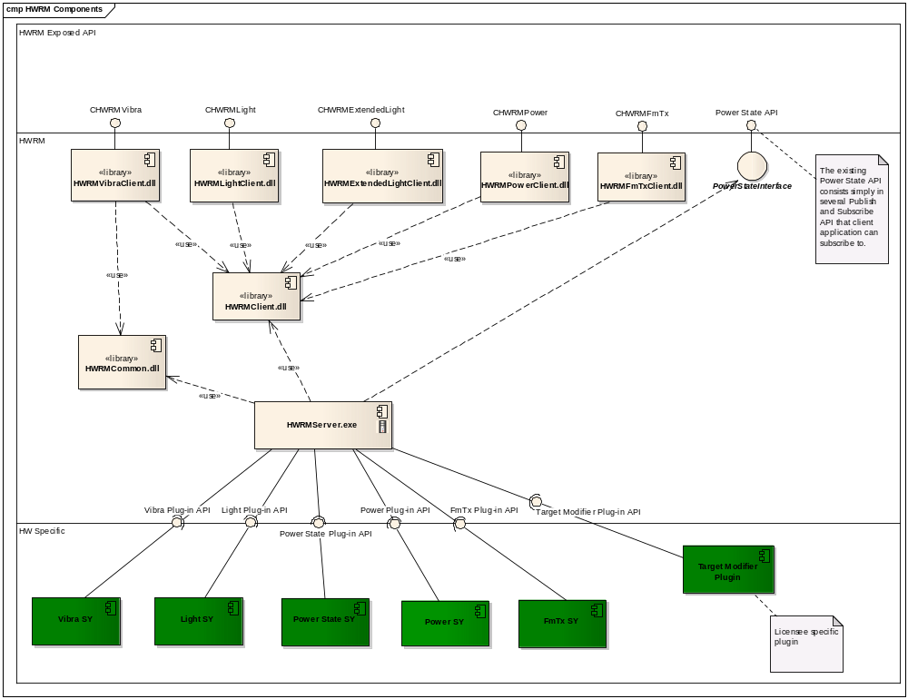
Figure 1.1 HWRM environment

Use cases
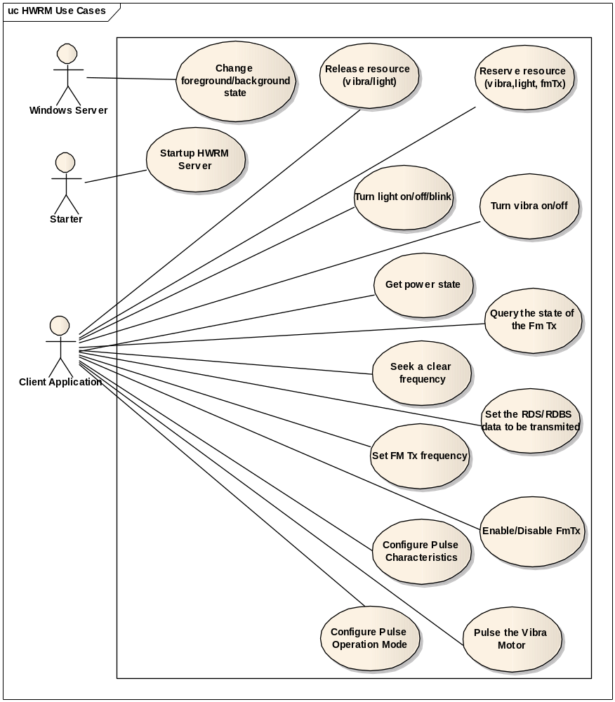
Figure 1.2 HWRM use cases
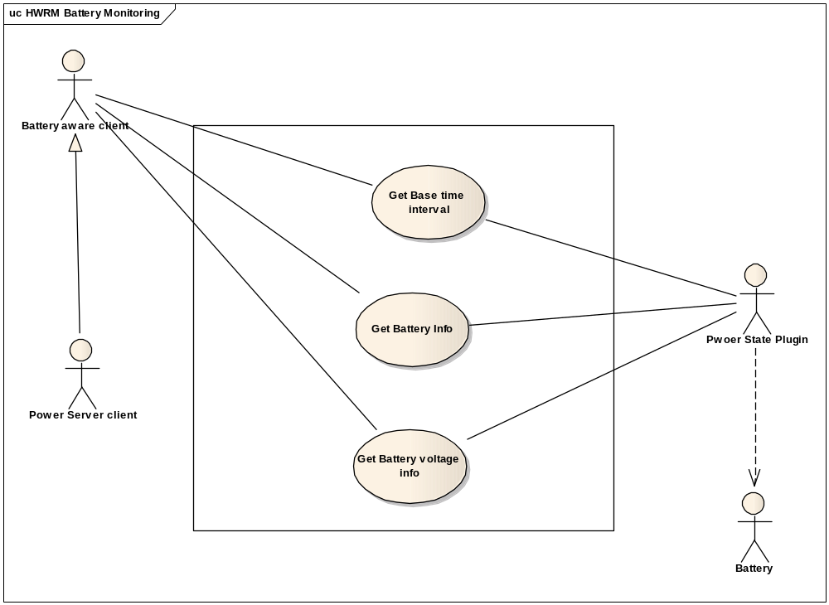
Figure 1.3 HWRM Power API use cases
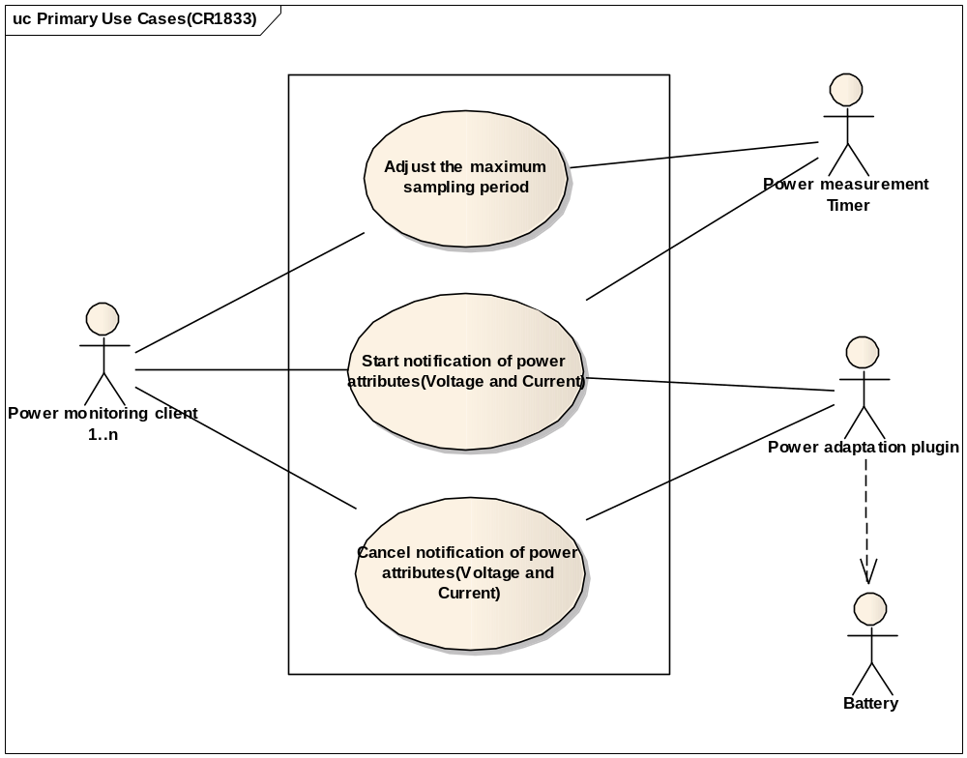
Figure 1.4 HWRM Power API use cases (Power Attribute, voltage and current, notification)

Starting HW Resource Manager Server

Summary | Starts HW Resource Manager Server.
Actor(s) | Starter.
Frequency | Once per boot.
Preconditions | HW Resource Manager not yet started.
Description | Starter starts up HW Resource Manager Server as part of device boot process. At startup HW Resource Manager Server initializes lights and power state adaptation plug-ins, and the target modifier plug-in for lights.  To optimize startup, vibra plug-in is not initialized; it is initialized when first vibra client requires it.  If any adaptation plug-in is missing, it is considered that device does not support that feature. If the target modifier plug-in is missing, targets are never modified.  HW Resource Manager Server is a protected system permanent server.
Exceptions
Postconditions | HW Resource Manager Server is ready.

Turning vibra on/off

Summary | Turning vibra on or off.
Actor(s) | Client application.
Frequency | Generally low. Some games and/or media applications may have high frequency, up to few times in second.
Preconditions | The device must support vibra.
Description | Vibra on: Client application specifies duration and intensity to be used (Default is an option). Various things are checked:  - Parameter validity (KErrArgument).  - Vibra enabled state from Central Repository (KErrAccessDenied).  - If current session has not reserved vibra, check if there is another session with active reservation (KErrInUse).  - If vibra has previously been used for a long period (i.e. it was forcibly cut off because duration was too long) and minimum cool-off period is still ongoing (KErrLocked).  - If vibra has been explicitly locked by some other service such as Accessory Server (KErrLocked).  - If vibra has been explicitly locked by HWRM internally because of charger connection (KErrLocked).  If all of the previous checks are passed, then HW Resource Manager Server starts vibra shutdown timer and instructs vibra plug-in to start vibra. If plug-in call is not executed in timely manner: KErrTimeout. When shutdown timer fires, HW Resource Manager Server instructs plug-in to stop vibra.  If vibra session is suspended, plug-in is not called, but desired state is stored in session and shutdown timer started.  Vibra off works similarly, except no timers or parameters are needed.  Whenever vibra state changes, all client applications are notified via Vibra client API callback. Clients may choose to not want to be informed, if status information is not needed.
Exceptions | All errors are propagated to client via leave mechanism.
Postconditions | Vibra is changed to desired state for desired duration.

Pulse the vibra motor

Summary | Pulse the vibra motor.
Actor(s) | Client application.
Preconditions | Vibra motor is not already on
Basic Flow | - The HWRM client requests to pulse the vibra supplying the duration and intensity.  - The HWRM server checks to see if vibra pulse mode is on.  - The HWRM server checks to see if vibra h/w is not in cooling off period.  - The HWRM server checks to see if the vibra resource is reserved by another client  - The HWRM server sends a request to the VibraSY plugin to pulse the vibra specifying the duration and intensity.
Alternate Flow 1 | (Client does not pass intensity or duration arguments)  - The HWRM client requests to pulse the vibra  - The HWRM server checks to see if the vibra resource is reserved by another client.  - The SID of client requesting the pulse is checked to check it is a registered pulse client.  The HWRM server sends a request to the VibraSY plugin to pulse the vibra specifying the default duration and intensity.
Alternate Flow 2 | (Vibra resource is already reserved by another client)  - The HWRM client requests to pulse the vibra supplying the duration and intensity.  - The HWRM server checks to see if the vibra resource is reserved by another client.  - THE HWRM server compares the priority of the client who has reserved the vibra and the client requesting the pulse.  - If reserved client has higher priority then pulse request fails  - If reserved client has lower priority then pulse request is invoked as normal
Alternate Flow 3 | (Vibra h/w in cool off period)  - The HWRM client requests to pulse the vibra supplying the duration and intensity.  - The HWRM server checks to see if vibra h/w is in cooling off period.  - If pulse mode enabled whilst in cool off period then invoke pulse request as normal.  - If pulse mode not enabled whilst in cool off period then fail request.
Exception Flow 1 | (Vibra mode is off)  - The HWRM client requests to pulse the vibra supplying the duration and intensity.  - The HWRM checks to see if the vibra mode is on.  - The request fails when vibra mode is off.
Exception Flow 2 | (client is not a registered pulse client)  - The HWRM client requests to pulse the vibra supplying the duration and intensity.  - The SID of client requesting the pulse is checked to check it is a registered pulse client.  - Client is not a registered pulse client.  Client pulse request is rejected.
Postconditions | Desired lights are changed to desired state for desired duration.

Overlapping vibra on and pulse requests, no reservations

User case | Overlapping vibra on and pulse requests, no reservations
Actor(s) | Client applications.
Preconditions | The device must support vibra. Vibra is not on. Vibra client1 and tactile feedback client2 have equal or different priorities.
Description | Client1->StartVibraL(3000, 10);  User::After(1000);  Client2->PulseVibraL(20, 50);
Exceptions | All errors are propagated to client via leave mechanism.
Post-conditions | Vibra is played for 1 second with intensity 10.  Vibra is then “pulsed” for 20 ms with intensity 50.  Vibra is then played for ~2 seconds with intensity 10.

Overlapping vibra on and pulse requests, reservations (case 1)

Summary | Overlapping vibra on and pulse requests, when reservation
Actor(s) | Client applications.
Preconditions | The device must support vibra. Vibra is not on. Vibra client1 has equal or higher priority than tactile feedback client2.
Description | Client1->ReserveVibraL();  Client1->StartVibraL(3000, 10);  User::After(1000);  Client2->PulseVibraL(20, 50);
Exceptions | All errors are propagated to client via leave mechanism.
Post conditions | Vibra is played for 3 seconds with intensity 10.  Client2->PulseVibraL completes with KErrInUse.

Overlapping vibra on and pulse requests, reservations (case 2)
Summary | Overlapping vibra on and pulse requests, when reservation
Actor(s) | Client applications.
Preconditions | The device must support vibra. Vibra is not on. Vibra client1 has lower priority than tactile feedback client2.
Description | Client1->ReserveVibraL();  Client1->StartVibraL(3000, 10);  User::After(1000);  Client2->PulseVibraL(20, 50);
Exceptions | All errors are propagated to client via leave mechanism.
Post conditions | Vibra is played for 1 second with intensity 10.  Vibra is then “pulsed” for 20 ms with intensity 50.  Vibra is then played for ~2 seconds with intensity 10.

Overlapping vibra on and pulse requests with reservations, lower priority client request resumed after release of vibra

Summary | Overlapping vibra on and pulse requests with reservations, lower priority client request resumed after release of vibra
Actor(s) | Client applications.
Preconditions | The device must support vibra. Vibra is not on. Vibra client1 has lower priority than client2.
Description | Client1->ReserveVibraL();  Client1->StartVibraL(5000, 10);  User::After(1000);  Client2->ReserveVibraL();  Client2->PulseVibraL(20, 50);  User::After(1000);  Client2->ReleaseVibraL();
Exceptions | All errors are propagated to client via leave mechanism.
Post conditions | Vibra is played for 1 second with intensity 10.  Vibra is then “pulsed” for 20 ms with intensity 50.  Vibra is then off for 1s.  Vibra then plays for further 1s.

Overlapping vibra on and pulse requests with reservations, lower priority client request expires whilst suspended

Summary | Overlapping vibra on and pulse requests with reservations, lower priority client request expires whilst suspended
Actor(s) | Client applications.
Preconditions | The device must support vibra. Vibra is not on. Vibra client1 has lower priority than client2.
Description | Client1->ReserveVibraL();  Client1->StartVibraL(5000, 10);  User::After(1000);  Client2->ReserveVibraL();  Client2->PulseVibraL(20, 50);  User::After(6000);  Client2->ReleaseVibraL();
Exceptions | All errors are propagated to client via leave mechanism.
Post conditions | Vibra is played for 1 second with intensity 10.  Vibra is then “pulsed” for 20 ms with intensity 50.  .

Turning lights on/off/blink

Summary | Turning lights on or off, or making them blink.
Actor(s) | Client application.
Frequency | Generally low. Some games and/or media applications may have high frequency, up to few times in second.
Preconditions | The device must support lights.
Description | Client application specifies a set of explicit lights target(s) or the system target, the duration (can be infinite) and other parameters depending on desired operation:  - Lights on: Intensity to be used (Default is an option; in that case intensity might be controlled by sensor depending on device settings.) and whether lights should fade in or not.  - Lights off: Whether lights should fade out or not.  - Lights blink: Intensity to be used (Default is an option) and blinking on/off cycle durations.  Various things are done next:  - Parameter validity is checked (KErrArgument).  - Currently inactive targets are stripped from the target using Target Modifier Plug-in.  - If current session has not reserved one or more of the remaining targets, check if there is another session with active reservation for those targets (KErrInUse).  If there are active targets left after inactive target removal and the checks described above are passed, then HW Resource Manager Server instructs lights plug-in to set lights state to the desired one. If duration was not infinite, a timer is also started that returns lights to the last infinite state they have been set by current session (called base state). If plug-in call is not executed in timely manner: KErrTimeout. When lights timer fires, HW Resource Manager Server instructs plug-in to restore the base state.  If target modification indicates a change in device configuration, active reserving sessions of newly (de)activated targets are notified about activation status change. Deactivated targets are always turned off and activated targets restored to their virtual state according to active reserving session. If no active reservation exists for activated target, there is no change in target state, i.e. it remains off.  If all specified light targets are in suspended mode for current session, plug-in is not called, but the desired state is stored in session and the timer started normally.  Whenever lights state changes, all client applications are notified via Light client API callback. Clients may choose to not want to be informed, if status information is not needed.
Exceptions | All errors are propagated to client via leave mechanism.
Postconditions | Desired lights are changed to desired state for desired duration.

Setting default RGB colour of light targets
Summary | Setting default RGB colour of light targets.
Actors | UI Application: Software component which requires access to the LEDs of the device. Target means LED of the device and it will be identified using a bit mask.  HWRM: Component provides device independent interfaces for accessing and controlling various hardware resources on the device. Also publishes the status of the light targets through a P&S key.  Light adaptation plug-in: An ECOM plug-in implements the HWRM light plug-in interfaces described by the HWRM server component. Supports various operations on the LED targets such as light on/off/blink. It also defines the default RGB colour for each of the supported LED targets on the device.
System Boundary | HWRM Client and Server
Pre-Conditions | - Successful connection to the HWRM server by the application.  - Device specific default RGB colour value for the LEDs defined by the light adaptation plug-in.
Basic Flow | - Application instantiates the light interface object and requests for setting the default RGB colour for the selected targets.  - HWRM client interface sends the request to the server to process.  - HWRM server checks if any of the requested targets are in use by the high priority application.  - HWRM server sends the command to light adaptation plug-in if it is not reserved and passes the reply back to the client.
Alternate Flow1 | During the launch of the HWRM server at start-up it loads the light adaptation ECOM plug-in.  If the light adaptation plug-in is failed to load or not present on the device then it returns KErrNotSupported.
Alternate Flow 2 | If the requested light targets are in use by the high priority application then it leaves with KErrInUse
Alternate Flow 3 | If the light adaptation plug-in does not support this feature(set default colour) then it returns KErrNotSupported.
Post-Conditions | Set the specific LED to its default colour value defined by the adaptation

Setting specific RGB colour of light targets
Summary | Setting specific RGB colour of light targets
Actors | UI Application, HWRM, Light adaptation plug-in – As in the previous use case
System Boundary | HWRM Client and Server
Pre-Conditions | Successful connection to the HWRM server by the application
Basic Flow | - Application instantiates the light interface object and requests for setting the specific RGB colour for the selected targets.  - HWRM client interface sends the request to the server to process.  - HWRM server checks if any of the requested targets are in use by the high priority application.  - HWRM server sends the command to light adaptation plug-in, along with the specified RGB colour value, if it is not reserved and passes the reply back to the client.
Alternate Flow 1 | If the requested light targets are in use by the high priority application then it leaves with KErrInUse
Alternate Flow 2 | If the light adaptation plug-in does not support this feature(set user defined colour) then it returns KErrNotSupported.
Post-Conditions | Light RGB colour setting will be set to the user defined value

Setting specific RGB colour of light targets for duration based operations
Summary | Setting specific RGB colour of light targets for duration based operations
Actors | UI Application, HWRM, Light adaptation plug-in – As in the previous use case
System Boundary | HWRM Client and Server
Pre-Conditions | Successful connection to the HWRM server by the application
Basic Flow | - Application instantiates the light interface object and requests for setting the specific RGB colour for the selected targets for duration based calls.  - HWRM client interface sends the light ON/OFF/BLINK request, for specific duration, to the server to process.  - HWRM server checks if any of the requested targets are in use by the high priority application.  - HWRM server sends the following two separate commands to the light adaptation to complete this request.  - Set colour command for specific RGB value  - Light ON/OFF/BLINK command with the specified duration  - HWRM server updates the light status as per the reply from the adaptation for the second command and reply back the error status to the client.  - Once the duration is completed then HWRM server restores the RGB value of the specified targets to its previous state.
Alternate Flow 1 | If the requested light targets are in use by the high priority application then it leaves with KErrInUse
Alternate Flow 2 | If the light adaptation plug-in does not support this feature(set user defined colour) then it returns KErrNotSupported.
Post-Conditions | Light RGB colour setting will be set to the specified value and the requested operation will be performed for the specified duration

Restoring previous RGB colour value for the client session – Priority based reservation
Summary | Restoring previous RGB colour value for the client session – Priority based reservation
Actors | UI application, HWRM and Light Adaptation Plug-in – As in the previous use case
System Boundary | HWRM Client and Server
Pre-Conditions | Successful connection to the HWRM server by the applications
Basic Flow | This is multi client use case which uses already existing use cases given in [R1] under the section 1.3.10 (Reserving a resource) and 1.3.11 (Releasing a resource).  - Client1 reserves a light target  - Client1 calls the set colour interface for that target. HWRM server stores the RGB value of this client session as last state.  - Client2 which is having high priority, over Client1, claims the successful reservation for the same target.  - Client2 changes the colour of the target using set colour interface. HWRM server stores the RGB value of this client session as last state.  - Client2 releases it now: In this case, the Client1 session will get the light target back and the HWRM restores the RGB colour setting (last state) for this session by sending the set colour command to the light adaptation plug-in.
Alternate Flow 1 | If a client request for reserving a light target is found to be not trusted then it returns KErrAccessDenied.  Trusted client’s SID, along with its priority value, should be given in the internal light policy file (ini file) before starting the HWRM server. A client can be defined trusted only by a product.
Alternate Flow 2 | If a client request for reserving a light target is already reserved by a high priority client then the requested client will be in suspended state and the HWRM will not delegate the request to the adaptation plug-in immediately.  Instead it stores the request as last state and it will be restored when the reservation state has been changed to active from suspended state.  More details on the reservation use case refer Section 1.3.10 from [R1].
Alternate Flow 3 | If the light adaptation plug-in does not support this feature (set user defined colour of a LED) then it returns KErrNotSupported.
Post-Conditions | The RGB colour value, for the specific target, for the Client 1 session will be restored.

Restoring default RGB colour value for the light targets – Priority based reservation
Summary | Restoring default RGB colour value for the light targets – Priority based reservation
Actors | UI application, HWRM and Light Adaptation Plug-in – As in the previous use case
System Boundary | HWRM Client and Server
Pre-Conditions | Successful connection to the HWRM server by the applications
Basic Flow | This is multi client use case which uses already existing use cases given in [R1] under the section 1.3.10 (Reserving a resource) and 1.3.11 (Releasing a resource).  - Client1 reserves a light target  - Client1 calls the set colour interface for that target. HWRM server stores the RGB value of this client session as last state.  - Client2 which is having high priority, over Client1, claims the successful reservation for the same target.  - Client2 changes the colour of the target using set colour interface. HWRM server stores the RGB value of this client session as last state.  - Client2 releases the light target. HWRM restores the RGB colour for the light target to Client1 session.  Client1 releases it now: Both the reservations have been released and there is no more reservation exists. In this case, HWRM sets the default colour RGB colour value for the light target
Alternate Flow | If the light adaptation plug-in does not support this feature (set default colour of a LED) then it returns KErrNotSupported.
Post-Conditions | The default RGB colour value for the light targets will be restored.

Reserving a resource

Summary | Reserving the vibra or one or more lights targets exclusively for client application.
Actor(s) | Client Application or HW Resource Manager.
Frequency | Low.
Preconditions | The device supports the selected resource.
Description | Reserves resource exclusively for client application. Resource can be vibra or one or more lights targets. Reservation will be immediately suspended if there exists a higher or equal priority reservation. Client can specify if the state of resource should be restored to what it was when this client last released the resource. If there has not been a previous release or client did not specify restoring, resource state will be unchanged by reservation.  SID of client application is checked against the policy file relating to resource being reserved. If SID is found, application is considered trusted. SID may also have nonstandard priority, which is also obtained from policy file. If SID is not found, client is not trusted and will have default priority.  Default behavior is that reservation and release are automatically done via notifications of application foreground/background state (see Section 1.3.17). Only trusted clients (i.e. clients that have their SID defined in policy) are allowed to disable this automation (KErrAccessDenied). As a result, untrusted clients can only reserve when there is CCoeEnv present (KErrBadHandle) and client application is on foreground (KErrNotReady).  When reservation is suspended, it still counts as reservation and therefore enables virtual use of resource. I.e. from client point of view, nothing changes. The only difference between suspended and active reservation is that the plug-in controlling the actual resource is not instructed to act when reservation is suspended.  In case of lights, it is checked that all specified targets are supported (KErrNotSupported).  Note that it is possible to use resources without reservation, but only if nobody else has reservation either.
Exceptions | All errors are propagated to client via leave mechanism.
Postconditions | Resource is reserved for client application.

Releasing a resource

Summary | Releasing the reservation of vibra or one or more lights targets.
Actor(s) | Client application or HW Resource Manager.
Frequency | Low.
Preconditions | The specified resource is reserved.
Description | Releases reservation of previously reserved resource. If the released reservation is currently suspended, it is simply deleted. If the released reservation is currently active, session with the highest priority suspended reservation is resumed, if any exists. In any case, the current state of the resource is frozen (i.e. stored), so that it can be restored on next reservation (see Section 1.3.15), if so desired. If there are no more suspended reservations, resource is also returned to its default state.  Resuming a suspended reservation restores the actual resource state to the same as the virtual state of the resource was during the suspension.
Exceptions | All errors are propagated to client via leave mechanism.
Postconditions | Resource is no longer reserved for client application.

Changing the foreground/background state

Summary | When application goes to background or comes to foreground, HW Resource Manager is notified.
Actor(s) | Window Server.
Frequency | Low.
Preconditions | Reservation with automatic background/foreground reservation control exists.
Description | HW Resource Manager is notified via foreground and background observers, provided by Windows Server, when client application goes to background or comes to foreground. If the client application in question has reservation that is automatically reserving based on background/foreground state (see Section 1.3.15), the reservation state changes accordingly: When application comes to foreground, resource is automatically reserved and when application goes to background, this reservation is automatically released. Automatic reservation always specifies that last released state must be restored, so resource state will be the same as it was when application went to background.
Exceptions
Postconditions | Resource is reserved or released according to the application foreground/background state.

Getting the power state

Summary | HW Resource Manager provides power state data to interested parties.
Actor(s) | Some application.
Frequency | Low.
Preconditions | Device supports power state data getting by providing Power State Plug-in adaptation.
Description | HW Resource Manager provides power state information to all interested parties via P&S. Provided data includes:  - Battery level  - Battery status  - Charging status
Exceptions
Postconditions | The application has the power state data it requires.

Getting the battery voltage information

Summary | Get battery voltage information
Actors | Power aware client, HWRM server, Power State Plug-in
Frequency | Medium
Pre-Conditions | none
Description | - Power aware client requests following battery voltage information  - Instant battery voltage  - Minimum battery voltage  - Maximum battery voltage  - HWRM server requests Power State Plug-in to retrieve information  - Power State Plug-in queries battery for information.  - Power State Plug-in completes request to server  - Server completes request to client.
Exceptions | Power State Plug-in does not support feature and returns KErrNotSupported
Post-Conditions | Information returned to client

Start battery power consumption (Voltage and Current together) measurements
Summary | Start battery power consumption (Voltage and Current) measurements
Actors | Power aware client, HWRM server, Power Adaptation Plug-in
Frequency | Medium
Pre-Conditions | none
Description | - Power aware client requests to start power consumption measurements, for both voltage and Current together, with time interval T.  - HWRM sends the request to Power Adaptation Plug-in.  - Power Adaptation plug-in returns success failure for starting measurements  - (If success) Power Adaptation Plug-in starts sampling battery power consumption attributes to calculate average for time interval T.  - HWRM server completes client’s start request.
Exceptions | - Power Adaptation Plug-in does not support feature and returns KErrNotSupported
Post-Conditions | Measurement information(Voltage and Current attribute together) returned to client

Enable the FM Transmitter

Description | Enabling the FM Transmitter.
Actors | Audio router server, Audio player
Pre-Conditions | The device must support FM Tx.
Basic Flow | - When enabling, the client application can specify an initial transmission frequency. Otherwise the previous (or default) is used.  - HWRM checks requested frequency is in range supported by h/w  - Request is passed to hardware for processing
Exceptions | Parameter validity (KErrArgument).  Mutually exclusive HW device active (KErrNotReady) e.g. tuner.  All errors are propagated to client via leave mechanism.
Post-Conditions | The FM transmitter is enabled. Clients are notified of the new frequency setting (if any). When enabled, the transmitter may be considered as an additional sink, for audio routing purposes.

Disable the FM Transmitter

Description | Disabling the FM Transmitter.
Actors | Audio router server, Audio player
Pre-Conditions | Fm Tx is on.
Basic Flow | Client requests FM transmitter to be disabled
Exceptions
Post-Conditions | The FM transmitter is disabled as requested  The transmitter is no longer able to be considered as a sink for audio routing purposes.

Set the FM Transmitter Frequency

Description | Setting the FM Transmitter frequency.
Actors | Audio router server, Audio player
Pre-Conditions | The device must support FM Tx. FM Tx may be enabled or disabled.
Basic Flow | - The client application specifies a new frequency, on which to transmit.  - HWRM checks new frequency is in range  - Request is passed to hardware for processing
Exceptions | Parameter validity (KErrArgument).  All errors are propagated to the client via a leave mechanism.
Post-Conditions | If FM Tx is on, transmission continues on the new frequency. The transmitter is still available as an additional output, for audio routing purposes. Clients are notified of the new frequency setting.

Seek a clear FM frequency

Description | Seeking a clear frequency
Actors | Audio router server, Audio player
Pre-Conditions | The device must support FM Tx. The transmitter must be enabled. Transmitter supports assisted frequency retuning.
Basic Flow | The client application requests an assisted frequency tuning feature.
Exceptions | RSSI/ RCPI scanning feature unsupported (KErrNotSupported).  FM Tx is disabled (KErrGeneral)  No clear channels found (KErrNotFound)  All errors are propagated to client via leave mechanism.
Post-Conditions | If clear frequencies are detected, those are returned to the client. Transmitter frequency is not changed.

Set RDS/RDBS to be transmitted

Description | Setting the RDS/ RDBS (almost identical standards) data to be transmitted
Actors | Audio router server, Audio player
Pre-Conditions | The device must support FM Tx. The transmitter must be enabled.
Basic Flow | The client application supplies the new RDS, Radiotext, and/or Radiotext+ data to be transmitted.
Exceptions | Parameter validity (KErrArgument). Note that RDS only supports a Latin character set  RDS feature unsupported (KErrNotSupported).  All errors are propagated to the client via a leave mechanism.
Post-Conditions | The new RDS data is stored. If FM Tx is on, then the new RDS data is transmitted.

Query the state of the FM transmitter

Description | Querying the state of the FM transmitter.
Actors | Audio router server, Audio player
Pre-Conditions | The device must support FM Tx.
Basic Flow | The client queries the current FM transmitter state.
Exceptions
Post-Conditions | The transmitter state is returned as requested.

External Dependencies

From the Symbian OS subsystems
Services of Symbian OS infrastructure including Central Repository, P&S, File Server, CONE and ECom are needed.
API | Description
Central Repository API | Central Repository holds the configuration data of HW Resource Manager.
Publish & Subscribe API | P&S is used to notify clients about resource status and power state.
CONE | Background/foreground status detection is required from CONE.
File Server | Policy files are stored in file system.
ECom | Plug-ins are loaded using ECom services.

From HW
This component has no direct HW interfaces. This component provides a plug-in interface for issuing control requests to the hardware to control the light, vibra, FM Transmitter and battery resources.

Services provided

UI
This component does not provide any UI.

SW IF

Provided service | Description | Protected
Light API | Provides methods to control various light targets of the device such as display and keyboard lights. For details, see Light API documentation in the Symbian OS Library. | No
Vibra API | Provides methods to control vibra of the device. For details, see Vibra API documentation in the Symbian OS Library. | No
Power API | Provides methods to request additional information regarding the battery of the device. For details, see Power API documentation in the Symbian OS Library | No
Power State API | Set of P&S keys to notify interested parties about power state. For details, see Power State API documentation in the Symbian OS Library. | Yes
FmTx API | Provides methods to control FM Transmitter of the device. For details, see FmTx API documentation in the Symbian OS Library. | Yes
Light Settings API | Central Repository API for lights related settings. For details, see Light API documentation in the Symbian OS Library. | Yes
Vibra Settings API | Central Repository API for vibra related settings. For details, see Vibra API documentation in the Symbian OS Library. | Yes
FmTx Settings API | Central Repository API for FmTx related settings. For details, see FmTx API documentation in the Symbian OS Library. | Yes

Design

Class diagrams
All C-classes inherit CBase at the bottom of inheritance chain.

HWRM Server
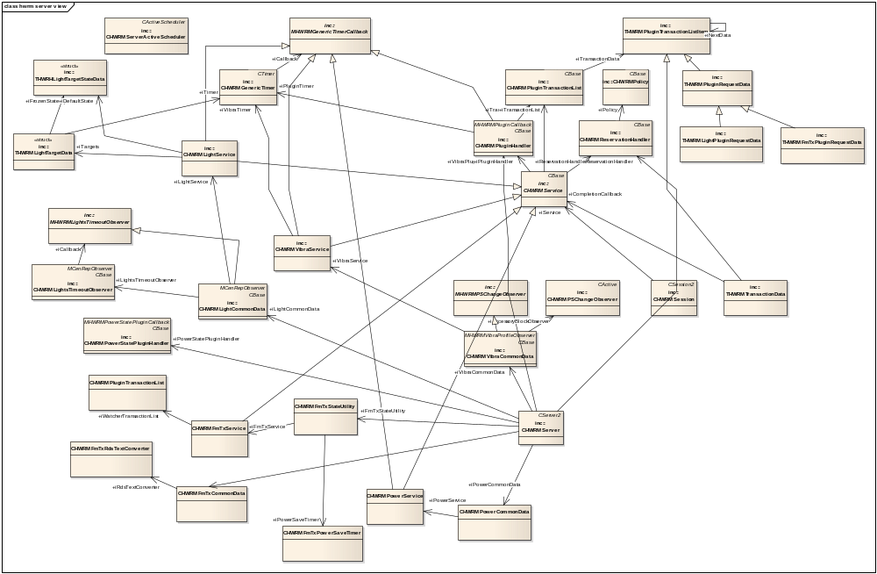
Figure 2.3 HWRM Server class diagram

HWRM Client
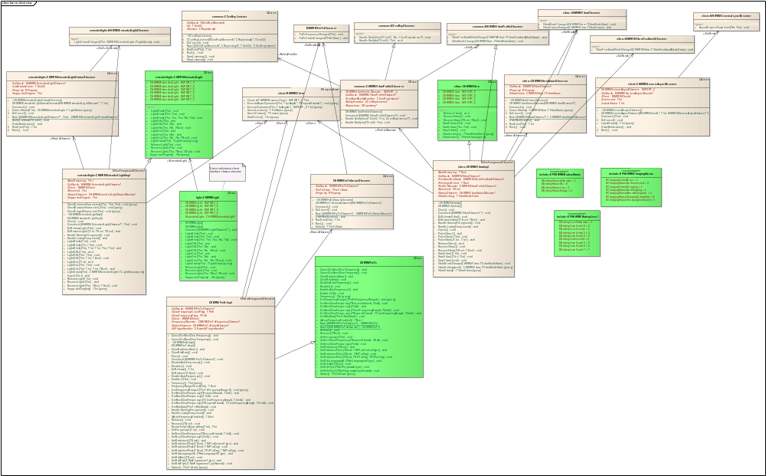
Figure 2.4 HWRM Client class diagram

HWRM Plug-ins
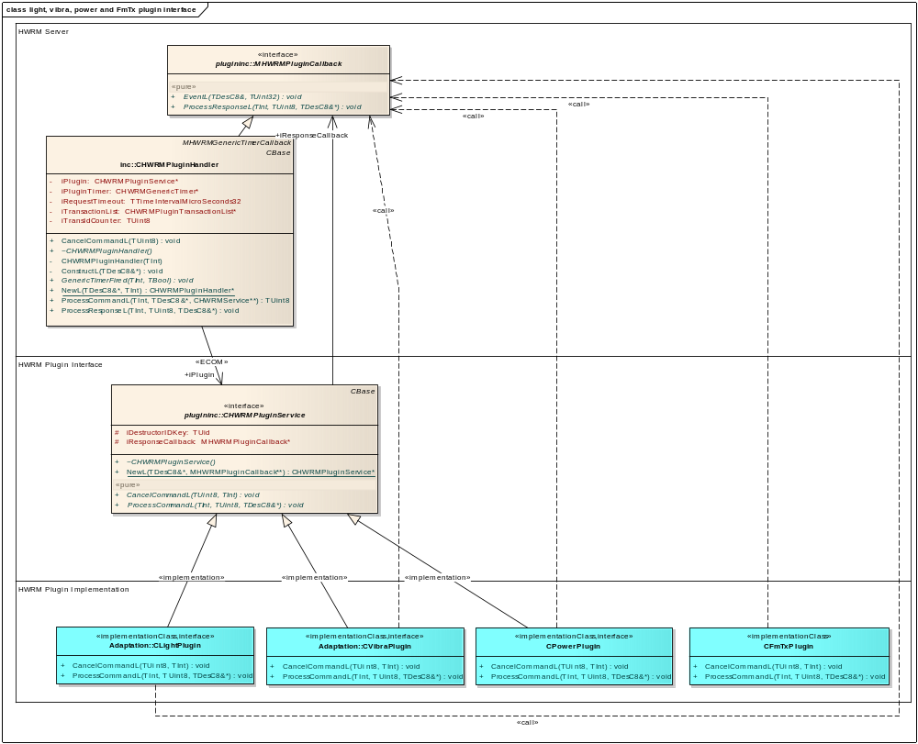
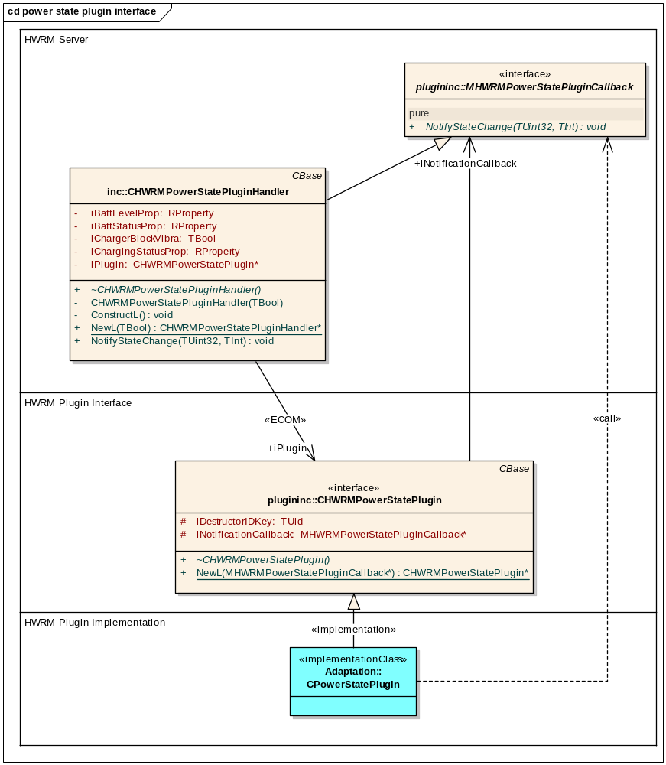
Figure 2.5 HWRM Resource Manager Plug-ins class diagram

Class descriptions

Class | Description | Header file
HWRM Server
CHWRMGenericTimer | Generic timer used for duration based resource state change timers and plug-in call timeout timer. | HWRMGenericTimer.h
CHWRMLightCommonData | Handles light related data that is common for all sessions, including settings stored in Central Repository. Also handles light state publishing to P&S. | HWRMLightCommonData.h
CHWRMLightService | Each light client session has an instance of this class. It handles most lights related issues, including lights related timers, lights state handling and commanding lights plug-in handler. | HWRMLightService.h
CHWRMPowerService | Each light client session has an instance of this class. It handles power related requests and commanding power plug-in handler. | HWRMPowerService.h
CHWRMPowerCommonData | Handles power related data that is common for all sessions, including settings stored in Central Repository. | HWRMPowerCommonData.h
CHWRMFmTxService | Each FmTx client session has an instance of this class. It handles FmTx related requests and commanding FmTx plug-in handler. | HWRMFmTxService.h
CHWRMFmTxCommonData | Handles FmTx related data that is common for all sessions, including settings stored in Central Repository. | HWRMFmTxCommonData.h
CHWRMFmTxRdsConverter | Utility for converting between Unicode and RDS text | HWRMFmTxRdsDConverter.h
CHWRMFmTxStateUtility | Handles FM Tx and Audio Routing state changes. Some events require plug-in requests to be sent automatically. | HWRMFmTxStateUtility.h
CHWRMFmTxPowerSaveTimer | Timer for FmTx Power Save | HWRMFmTxPowerSaveTimer.h
CPolicyClient | Embedded class of CHWRMPolicy to contain policy client data intended to be read from the policy files. | HWRMPolicy.h
CHWRMPowerState  PluginHandler | Handles power state plug-in loading and observing as well as publishing power state P&S properties. | HWRMPowerStatePluginHandler.h
CHWRMPSChangeObserver | Generic observer for P&S property value changes, one instance for each property. | HWRMPSChangeObserver.h
CHWRMReservation  Handler | Handles and stores reservations. | HWRMReservationHandler.h
CHWRMServer | Server main class. Owns reservation and plug-in handlers, as well as vibra and light common data objects. | HWRMServer.h
CHWRMServerActive  Scheduler | Active Scheduler used by HW Resource Manager Server. | HWRMServerActiveScheduler.h
CHWRMService | Base class for vibra and light services. | HWRMService.h
CHWRMSession | Server side class for client sessions. Owns service related to session. Each session can only serve one type of resource. | HWRMSession.h
CHWRMVibraCommonData | Handles vibra related data that is common for all sessions, including settings stored in CenRep. Also handles vibra state publishing to P&S. | HWRMVibraCommonData.h
CHWRMVibraService | Each vibra client session has an instance of this class. It handles most vibra related issues, including vibra related timers, vibra state handling and commanding vibra plug-in handler. | HWRMVibraService.h
MHWRMLightsTimeout  Observer | Pure virtual callback interface for CHWRMLightsTimeoutObserver class. | HWRMLightsTimeoutObserver.h
MHWRMPowerStatePluginCallback | Pure virtual callback interface for power state plug-in. | HWRMPowerStatePlugin.h
MHWRMPSChangeObserver | Pure virtual callback interface for the CHWRMPSChangeObserver class. | HWRMPSChangeObserver.h
THWRMLightPluginRequestData | Data storage class for light plug-in requests. | HWRMLightService.h
THWRMLightTargetData | Data struct for light target specific data. | HWRMLightService.h
THWRHLightTargetStateData | Data struct for storing single light target state. | HWRMLightService.h
THWRMPluginRequest  Data | Data storage class for generic plug-in requests. | HWRMService.h
THWRMPluginTrans  actionListItem | Plug-in transaction data items base class. | HWRMPluginTransactionList.h
THWRMTransactionData | Contains ongoing plug-in transaction data. | HWRMPluginHandler.h
HWRM Client
CHWRMLight | Abstract class defining lights client API. | HWRMLight.h
CHWRMLightImpl | Lights client API implementation. | HWRMLightImpl.h
CHWRMLightStatus  Observer | Observes light status P&S variable that is set by HW Resource Manager Server and notifies the client via callback interface. | HWRMLightStatusObserver.h
CHWRMExtendedLight | Abstract class defining extended lights client API. | HWRMExtendedLight.h
CHWRMExtendedLightImpl | Extended lights client API implementation. | HWRMExtendedLightImpl.h
CHWRMExtendedLightStatusObserver | Observes extended light status P&S variable that is set by HW Resource Manager Server and notifies the client via callback interface. | HWRMExtendedLightStatusObserver.h
CHWRMVibra | Abstract class defining vibra client API. | HWRMVibra.h
CHWRMVibraImpl | Vibra client API implementation. | HWRMVibraImpl.h
CHWRMPower | Class defining Power client API. | HWRMPower.h
CHWRMPowerImpl | Power client API implementation | HWRMPowerImpl.h
CHWRMBatteryVoltageMeasurementsAO | Used to receive notification from HWRM server when voltage measurements are received | HWRMBatteryVoltagMeasurementsAO.h
CHWRMBatteryConsumptionMeasurementsAO | Used to receive notification from HWRM server when consumption measurements are received | HWRMBatteryConsumptionMeasurementsAO.h
CHWRMBatteryPowerMeasurementsAO | Used to receive notification from HWRM server when power consumption measurements(voltage and current together) are received | HWRMBatteryPowerMeasurementsAO.h
CHWRMVibraStatus  Observer | Observes light status P&S variable that is set by HW Resource Manager Server and notifies the client via callback interface. | HWRMVibraStatusObserver.h
MHWRMLightObserver | Pure virtual callback interface for light status change notifications. | HWRMLight.h
MHWRMVibraObserver | Pure virtual callback interface for vibra status and mode change notifications. | HWRMVibra.h
MHWRMBatteryVoltageObserver | Pure virtual callback interface for voltage measurements notifications | HWRMPower.h
MHWRMBatteryConsumptionObserver | Pure virtual callback interface for consumption measurements notifications | HWRMPower.h
RHWRMClient | Client side HW Resource Manager Server session implementation. | HWRMClient.h
CHWRMEnhancedLight | Abstract class defining extended lights client API with RGB color support. | HWRMEnhancedLight.h
HWRM Plug-ins
CHWRMLightCommands | A namespace rather than a class. Contains command identifiers and package definitions for interacting with light plug-in. | HWRMLightCommands.h
CHWRMPluginService | Defines plug-in API for vibra and lights plug-ins. | HWRMPluginService.h
CHWRMVibraCommands | A namespace rather than a class. Contains command identifiers and package definitions for interacting with vibra plug-in. | HWRMVibraCommands.h
CHWRMPowerStatePlugin | Defines plug-in API for power state plug-in. | HWRMPowerStatePlugin.h
CHWRMTargetModifierPlugin | Defines plug-in API for HWRM Target Modifier Plug-in. | HWRMTargetModifierPlugin.h
HWRMPowerCommand | A namespace. Contains command identifiers and package definition for interacting with power plug-in | HWRMPowerCommands.h
HWRM Common classes | These classes are used by multiple subcomponents of HW Resource Manager.
CHWRMVibraProfile  Observer | Observes the changes in value of the KVibraCtrlProfileVibraEnabled Central Repository key and notifies interested parties via MHWRMVibraProfileObserver interface. | HWRMVibraProfileObserver.h
MHWRMVibraProfile  Observer | Pure virtual interface implemented by classes that need to observe vibra mode changes in profile settings. | HWRMVibraProfileObserver.h
- | Trace macros utilized by all components. | HWRMTrace.h

Structs, type definitions and enumerations
Some struct definitions are included in class definitions above as they are also included in class diagram. The rest are thoroughly commented in code where they are defined.
Some notes about structs, type definitions and enumerations used in HW Resource Manager:
- Resource plug-in APIs require data to be passed as 8-bit descriptor. Each command has a struct (if more than one parameter) and a package buffer type definition for that purpose.
- Same concept is used in client-server interface of HW Resource Manager.
- Both HWRMLight.h and HWRMLightCommands.h define TLightTarget enumeration. Neither one of these headers can be comfortably used in both light plug-in and light client API DLL, so this duplication is necessary, as additional header for just light target is not desirable either. These enumerations must stay logically equivalent.

Flag definitions

Flag | Description
API_TRACE_FLAG | When this flag is defined, components output trace whenever public API method is entered and exited.
COMPONENT_TRACE_FLAG | When this flag is defined, components output miscellaneous trace. If neither of these trace flags is defined, no trace is produced by HW Resource Manager.

Operations
Not all operations related to vibra are described here, as they are very similar to the corresponding light operations, with the exception that light operations can have multiple targets while there is ever at most one vibra in the device. Omitted operations include reservation, release, and creation of session and client notifications.

Starting HW Resource Manager Server

Operation | Starting HWRM Server.  TInt E32Main()
Preconditions | Starter is running.
Description | Starter starts HW Resource Manager Server as part of its startup list.
Inputs
Modifies | E32Main()creates a new instance of CHWRMServer and installs a new CHWRMServerActiveScheduler.  At startup CHWRMServer creates:  - An instance of CHWRMPluginHandler for lights (which in turn loads correct implementation of CHWRMPluginService). Correct plug-in service implementation is identified by the IMPLEMENTATION_INFO element default_data = "HWRMLight" of plug-in resource file.  - An instance of CHWRMReservationHandler for lights (which in turn creates correct CHWRMPolicy)  - An instance of CHWRMLightCommonData, which in turn also creates an instance of CHWRMTargetModifierPlugin using ECom.  - An instance of CHWRMPowerStatePluginHandler.  If light plug-in handler cannot be created, it is considered to indicate that device does not support lights. In that case no reservation handler or common data is created either.  Vibra and power related handlers and common data are not created at startup to optimize startup speed. They are created when any client first requests vibra or battery/power service.  HW Resource Manager Server is set as system permanent process.
Outputs
Postconditions | HW Resource Manager Server is up and running. If there was unrecoverable problem, system reboots, as HW Resource Manager Server is a system permanent process.
Related To | CHWRMServer  CHWRMServerActiveScheduler  CHWRMPluginHandler  CHWRMReservationHandler  CHWRMLightCommonData  CHWRMPowerStatePluginHandler  CHWRMTargetModifierPlugin  See the use case in Section 1.3.1.
Related Event | Starter starts HW Resource Manager Server process.
Exceptions | If light or vibra policy file is missing, HW Resource Manager Server fails to initialize reservation handler. In that case a resource is considered to be unsupported and no client sessions for it will be allowed.  If some required CenRep file is missing, HW Resource Manager Server fails to initialize common data for the resource. In that case resource is considered to be unsupported and no client sessions for it will be allowed.  See Sections 3.1 and 3.2.2 for required files.

Creating a light session

Operation | Creating a light session.  static CHWRMLight* CHWRMLight::NewL();  static CHWRMLight* CHWRMLight::NewLC();  static CHWRMLight* CHWRMLight::NewL(MHWRMLightObserver* aCallback);  static CHWRMLight* CHWRMLight::NewLC(MHWRMLightObserver* aCallback);
Preconditions | HW Resource Manager Server is started.
Description | Light session is created for client to interact with lights.
Inputs | If light status and suspension information callbacks are desired, callback pointer must be provided.
Modifies | Creates a new client side instance of CHWRMLight (actually CHWRMLightImpl) and corresponding server side CHWRMSession and CHWRMLightService instances.
Outputs | Instance of CHWRMLight for client to use or a NULL pointer if creation fails.
Postconditions | Light session client side object is ready to be used.
Related To | CHWRMSession  CHWRMLightService  CHWRMServer
Related Event | Calling one of the factory methods specified in operation field.
Exceptions | KErrNotSupported – If device does not support lights.

Lights on/off/blink

Operation | Set lights to specific state (on, off or blink).  void CHWRMLight::LightOnL(TInt aTarget);  void CHWRMLight::LightOnL(TInt aTarget, TInt aDuration);  void CHWRMLight::LightOnL(TInt aTarget, TInt aDuration, TInt aIntensity, TBool aFadeIn);  void CHWRMLight::LightOffL(TInt aTarget);  void CHWRMLight::LightOffL(TInt aTarget, TInt aDuration);  void CHWRMLight::LightOffL(TInt aTarget, TInt aDuration, TBool aFadeOut);  void CHWRMLight::LightBlinkL(TInt aTarget);  void CHWRMLight::LightBlinkL(TInt aTarget, TInt aDuration);  void CHWRMLight::LightBlinkL(TInt aTarget, TInt aDuration, TInt aOnDuration, TInt aOffDuration, TInt aIntensity);
Preconditions | Light client session exists.
Description | Light state of specified light targets is changed.
Inputs | aTarget: (on/off/blink) Defines which light should be controlled. Multiple lights can be specified with using bitwise-or. If the system target is specified, other specified targets are ignored.  aDuration: (on/off/blink) Duration of the time the light is switched on/off/blink measured in milliseconds. After the duration expires, the light state for target will be changed to whatever state was caused by the last infinite time duration call, or the default state determined by inactivity timer, in case there has not been a previous infinite time duration call in this session. If the aDuration time is KHWRMInfiniteDuration then it means an infinite value that has to be stopped by calling of any of the other light control methods. Duration can have maximum value of KHWRMLightMaxDuration.  aIntensity: (on/blink) Intensity of the light. If aIntensity is KHWRMDefaultIntensity, device default intensity will be used for targets that do not support sensor. For sensor supporting targets, default sensitivity is used. Note that all devices may not support user-defined intensity, in which case device will behave in its default fashion.  aFadeIn: (on) If ETrue, lights will not turn on instantly but instead smoothly fade-in. Note that not all devices support fade-in, in which case device will behave in its default fashion.  aFadeOut: (off) If ETrue, lights will not turn off instantly but instead smoothly fade-out Note that not all devices support fade-out, in which case device will behave in its default fashion.  aOnDuration/aOffDuration: (blink) Duration time, measured in milliseconds, of how long the light is switched on/off in every blink cycle. Duration can have maximum value of KHWRMLightMaxDuration. For device default cycle duration, use value KHWRMDefaultCycleTime. If either of aOnDuration or aOffDuration is KHWRMDefaultCycleTime, both must be KHWRMDefaultCycleTime. Some devices might not support variable blink cycle times, in which case default value will be substituted.
Modifies | CHWRMLightService instance related to this session will change the lights’ virtual state as specified, except for targets that are edited out by Target Modifier Plug-in. If some of the specified targets were not suspended nor reserved to any other session, also calls corresponding function on lights plug-in to set actual HW lights state.  If sensor is supported in the device each target can either support sensor or not, and depending on that, the used lights plug-in command varies. It is possible to have both sensor supporting and non-sensor supporting targets in single command, in which case the command is split into two lights plug-in transactions. Original client call is not completed until both transactions are processed.  If the system target is specified, other targets are ignored and the target is replaced by full system target mask before modification by Target Modifier Plug-in.  If target modification results in (de)activating targets that were previously in other activation state, currently active reserving session for those targets is notified about activation state change. See Section 2.3.11.  If duration was specified, a CHWRMGenericTimer object will be used to time the duration. Timers are target specific. When a timer fires, base state of corresponding target is returned, or if target has no base state (i.e. infinite duration on/off/blink has not been called for it by this session), the default state is returned instead. Default state is either on or off, determined by inactivity time.
Outputs | Changed actual HW lights state is notified to light clients. If there is an error within asynchronous plug-in call, notified state will be ELightStatusUnknown.
Postconditions | Lights state of device has changed. In case of error, HW lights state does not change, and virtual state of light service may or may not change, depending on where the error occurred: If error occurs within asynchronous plug-in call, the virtual state changes; otherwise it remains unchanged.
Related To | CHWRMPluginHandler  CHWRMReservationHandler  CHWRMSession  CHWRMLightService  CHWRMLightCommonData  CHWRMGenericTimer  CHWRMTargetModifierPlugin  See the use case in Section 1.3.9.
Related Event | Calling one of the methods specified in operation field.
Exceptions | KErrArgument: One of the parameters is out of range.  KErrNotSupported: One or more of specified targets are not supported.  KErrBadHandle: If light session has been invalidated.  KErrTimedOut: If timeout occurred in controlling light.  KErrInUse: If one or more of specified targets are reserved for others.

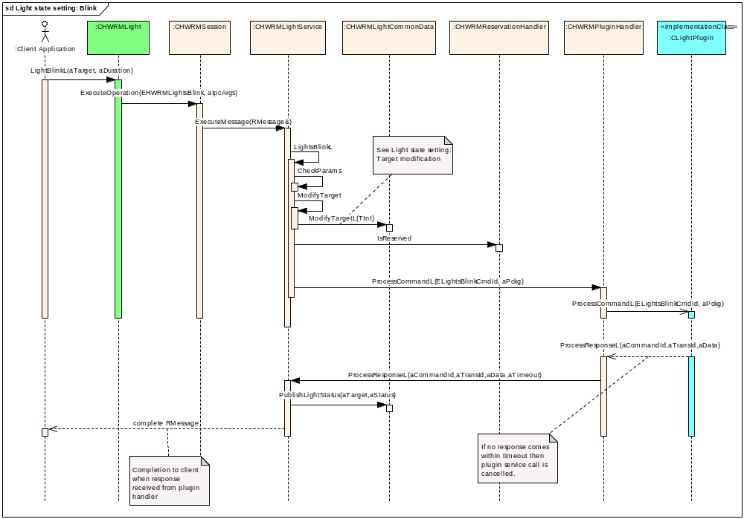
Figure 2.6 Lights state setting: Blink
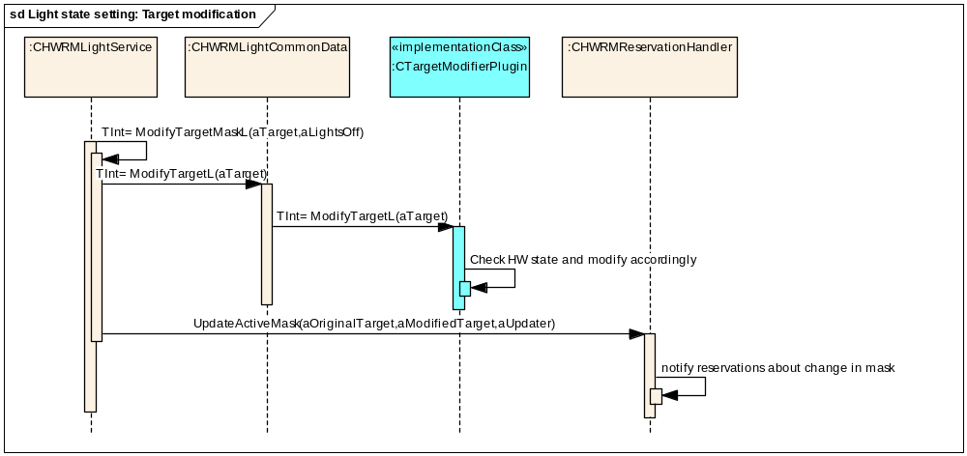
Figure 2.7 Lights state setting: Target modification

Setting RGB Color
The software component or application interested in changing the RGB colour parameter for a light (LED) target on the device shall be able to set it through new HWRM light client interface.
- This design introduces new APIs in the HWRM light client interface CHWRMLight. This interface supports for about 10 light resources on the device.
- Also it introduces a new interface CEnhancedLight, in the HWRM extended light client interface. This interface supports for about 32 light resources on the device.
- These light client interfaces shall provide separate APIs for setting the user defined RGB colour, which accepts the colour intensity value for Red/Green/Blue, and setting the default RGB colour of the specific light targets.
- If the requested light resource is not reserved already then HWRM delegate this request to the light adaptation plug-in to process. It is a synchronous API and it blocks the client till it receives the response back from the plug-in.

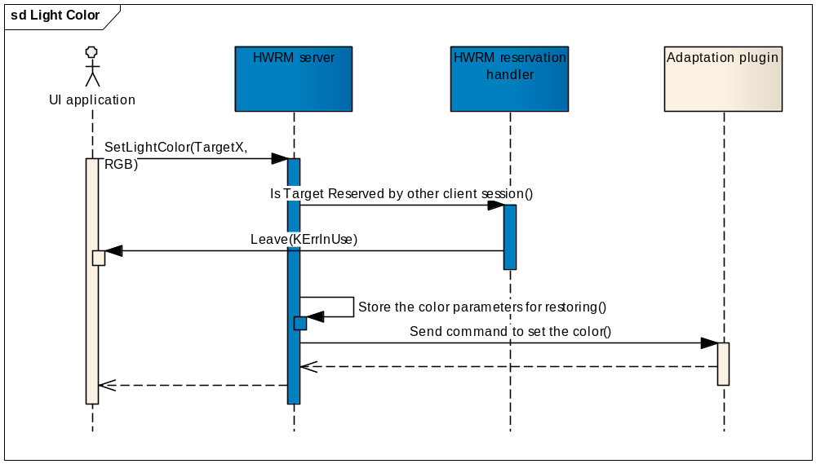
Figure – Sequence diagram for setting RGB colour
- The proposed design extends the existing duration based light operation (ON/OFF/BLINK) APIs to accept RGB intensity values.
- HWRM shall split this client request to two separate commands to set the colour and do the requested operation which will be sent to the light adaptation. A timer shall be started, for the specified duration, to stop the requested operation. It shall use the existing support of split command handling in the plug-in handler.
- Once the request timer expires then the previous client specific RGB colour setting shall be restored by sending a separate command to the light plug-in.

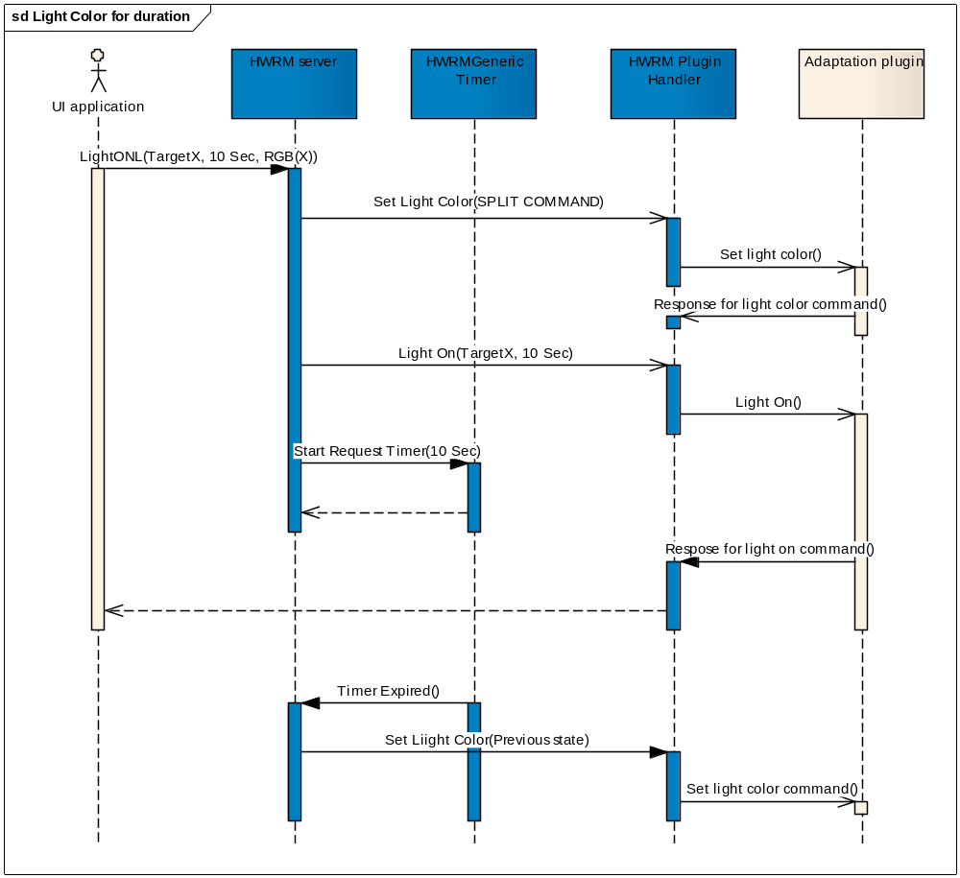
Figure – Sequence diagram for setting RGB colour for duration based calls

Restoring RGB Color
The HWRM reservation controller offers priority based reservation for a supported resource on the device. The priority of each client requesting for the access to the specific resource shall be given in resource specific policy file which will be parsed during the resource initialisation time by the HWRM server.
- The design extends the functionalities of reserve and release APIs, in HWRM light client interface, to restore the RGB colour of the interested light resources.
- HWRM stores the RGB colour parameters every time when the client changes the RGB colour for a light resource.
- At the time of reserving a light resource by a client session, the last RGB colour value set by the client will be restored by sending the command to adaptation plug-in.
- At the time of releasing the light resource by a client session, if it is the last client to release then the default RGB colour value for the specific light resource will be restored by sending the appropriate adaptation command.
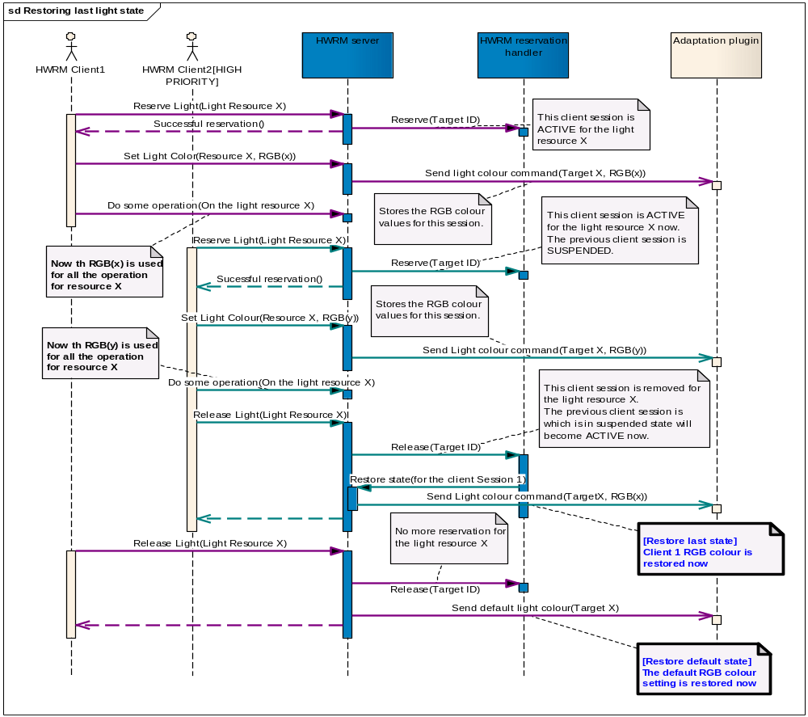
Figure – Sequence diagram for restoring last/default RGB colour setting

Vibra on/off

Operation | Setting the vibra on or off.  void CHWRMVibra:: StartVibraL (TInt aDuration);  void CHWRMVibra:: StartVibraL (TInt aDuration , TInt aIntensity);  void CHWRMVibra:: StopVibraL ();
Preconditions | Vibra client session exists.
Description | Vibra state is changed.
Inputs | aDuration: Duration of the vibration measured in milliseconds. A value of 0 specifies that the vibration should continue indefinitely and should be stopped with a call to StopVibraL. Duration can have maximum value of KHWRMVibraMaxDuration.  aIntensity: Intensity of the vibra in decimal is -100 to 100, which shows the percentage of the vibra motor full rotation speed. When intensity is negative, the vibra motor rotates in the negative direction. When intensity is positive, the vibra motor rotates in the positive direction. Value 0 stops the vibra. Note: The device may have hardware imposed limits on supported vibra intensity values, so the actual effect may vary between different hardware.
Modifies | CHWRMVibraService instance related to this session changes vibra virtual state as specified. If vibra is not suspended nor reserved to any other session, also calls corresponding function on vibra plug-in to set actual HW vibra state.  If duration was specified, a CHWRMGenericTimer object will be used to time the duration. Maximum allowed time is configurable via Vibra Settings CenRep API; see Section 3.2.2. When the timer fires, base state of vibra is returned (i.e. vibra is turned off).
Outputs | Changed actual HW vibra state is notified to vibra clients. If there is an error within asynchronous plug-in call, notified state will be EVibraStatusUnknown.
Postconditions | Vibra state of device has changed. In case of error, HW lights state does not change, and virtual state of light service may or may not change, depending on where the error occurred: If error occurs within asynchronous plug-in call, the virtual state changes; otherwise it remains unchanged.
Related To | CHWRMPluginHandler  CHWRMReservationHandler  CHWRMSession  CHWRMVibraService  CHWRMVibraCommonData  CHWRMGenericTimer  See the use case in Section .
Related Event | Calling one of the methods specified in operation field.
Exceptions | KErrNotSupported: Device does not support user-defined vibra intensity.  KErrArgument: One of the parameters is out of range.  KErrAccessDenied: If vibration setting in the user profile is not set.  KErrBadHandle: If vibra session has been invalidated.  KErrLocked: If vibra is locked down because too much continuous use or explicitly blocked by, for example, some vibration sensitive accessory or charger.  KErrTimedOut: if timeout occurred in controlling vibra.  KErrInUse: if vibra is not reserved to this client but to some other client.

Reserving lights

Operation | Reserving lights for a session.  void CHWRMLight::ReserveLightL(TInt aTarget)  void CHWRMLight::ReserveLightL(TInt aTarget, TBool aRestoreState, TBool aForceNoCCoeEnv)
Preconditions | Lights client session with some unreserved targets exists.
Description | Lights are reserved for a client session.
Inputs | aTarget: Defines which light should be reserved. Multiple lights can be specified with using bitwise-or.  aRestoreState: If ETrue, the state frozen on last release will be restored upon successful reservation. I.e. if light was blinking when this client released it the last time, it would start blinking again upon successful reservation. For the first reservation of each session this parameter is always considered EFalse regardless of what is supplied, as there is no previous frozen state to restore.  aForceNoCCoeEnv: If EFalse, then reservation requires that this client is on the foreground at the time of reservation and light target will be automatically released and re-reserved based on background/foreground status of the this client. This also implies that CCoeEnv::Static() != NULL is required. If ETrue, the client will not require CCoeEnv to be present nor does it automatically reserve/release light by depending on foreground/background status of the client. Only trusted clients are allowed to set this flag to ETrue. Client is considered trusted if it has nonstandard priority defined in the lights policy.
Modifies | CHWRMReservationHandler object for lights will create new reservations for targets, unless one already exists for all specified targets. New reservations can be immediately suspended, if corresponding target already has equal or higher priority reservation.  Lights state can be modified; see the aRestoreState parameter description above.  If reservation causes suspension of previously active reservation for some targets, specified targets in sessions related to those reservations will be suspended.
Outputs
Postconditions | Specified light targets are reserved to client session. If any error occurs, reservations are not affected.
Related To | CHWRMReservationHandler  CHWRMSession  CHWRMLightService  See the use case in Section 1.3.15.
Related Event | Calling one of the methods specified in operation field.
Exceptions | KErrNotSupported: One or more of specified targets are not supported.  KErrAccessDenied: If aForceNoCCoeEnv is ETrue and client is not trusted.  KErrBadHandle: If aForceNoCCoeEnv is EFalse and no CCoeEnv present.  KErrNotReady: If trying to reserve while on background and aForceNoCCoeEnv is EFalse.

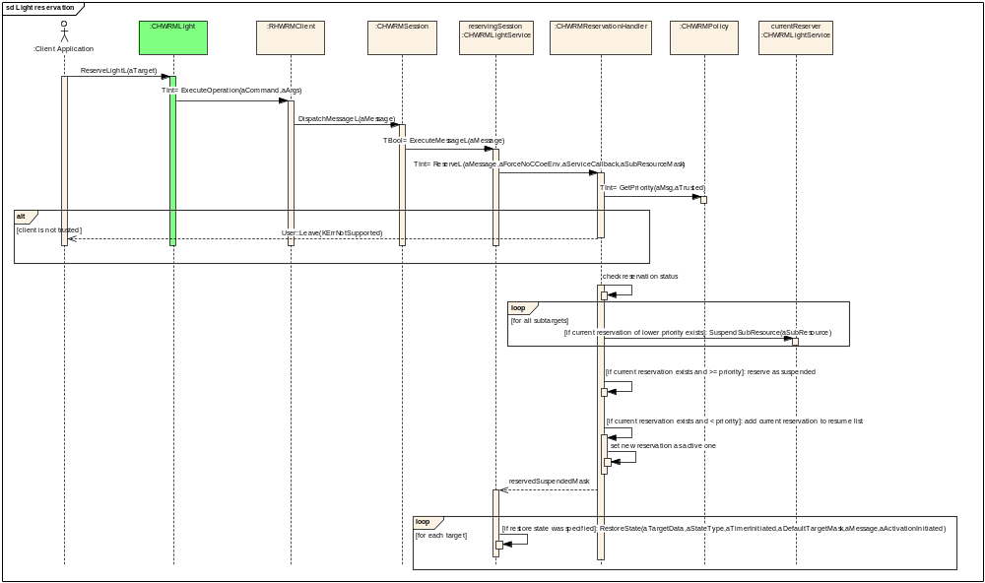
Figure 2.8 Light reservation
Reservation handler stores reservations in pointer array that has always as many items as there are sub-resources to be reserved. In lights case, this is equivalent to the number of light targets. If the pointer in index n is NULL, then there is no reservation for sub-resource n. Reservations are represented by instances of the TReservationData class, which can act as nodes in a linked list. The pointer array can only contain pointers to currently active reservation data objects. If a sub-resource has also suspended reservations in addition to active one, the active data has a pointer to first suspended data, which in turn points to next suspended data, etc.

Releasing lights

Operation | Releasing lights for a session.  void CHWRMLight::ReleaseLight(TInt aTarget)
Preconditions | Light session with some reserved targets exists.
Description | Lights are released for a client session.
Inputs | aTarget: Defines which light should be released. Multiple lights can be specified with using bitwise-or.
Modifies | CHWRMReservationHandler object for lights will delete released reservations. If deleted reservation was active, next one in priority order will be activated, if any exists. If no suspended reservations exist for some targets, those targets will be returned to their default state.  If release causes activation of suspended reservations, specified targets in sessions related to those reservations will be resumed.
Outputs
Postconditions | Specified light targets are released from client session. If any error occurs, reservations are not affected.
Related To | CHWRMReservationHandler  CHWRMSession  CHWRMLightService  See the use case in Section 1.3.16.
Related Event | Calling one of the methods specified in operation field.
Exceptions

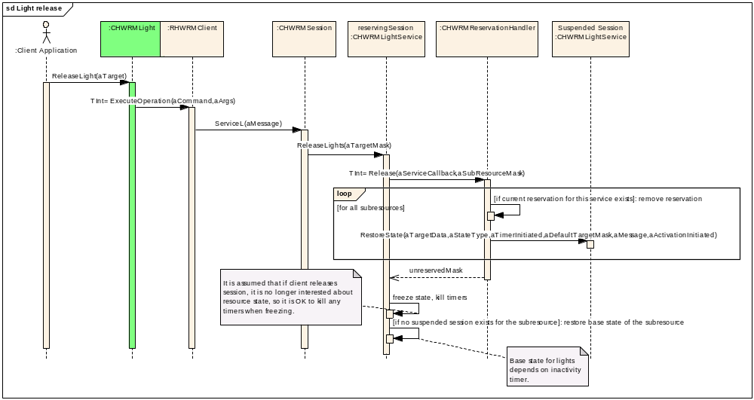
Figure 2.9 Light release

Suspending light reservation

Operation | Suspending reservation of lights.  void CHWRMLightService::SuspendSubResource(TInt aSubResource)
Preconditions | Higher or equal priority reservation exists for lights target that is being reserved, or a new higher priority reservation comes for a target.
Description | Active reservation of target is suspended.
Inputs | Index in target light array indicating target.
Modifies | Marks target suspended in CHWRMLightService object.
Outputs
Postconditions | A light target reservation is suspended.
Related To
Related Event | See Section 2.3.7.
Exceptions

Resuming light reservation

Operation | Activating the reservation of lights.  void CHWRMLightService::ResumeSubResource(TInt aSubResource)
Preconditions | A reservation is suspended and the next-higher priority reservation has been released.
Description | Suspended reservation of target is activated.
Inputs | Index in target light array indicating target.
Modifies | Removes suspension from target in the CHWRMLightService object. Also restores the last virtual state for this target to actual lights target.
Outputs
Postconditions | A light target reservation is resumed.
Related To | See Section 2.3.3.
Related Event | See Section 2.3.8.
Exceptions

(De)Activating light target

Operation | (De)Activating a target.  void CHWRMLightService:: ActivateSubResource(TInt aSubResource, TBool aActivate)
Preconditions | Session has the active reservation of the light target to be (de)activated.
Description | Activation status for targets is determined by comparing the original target mask to the modified target mask after Target Modifier Plug-in modifies target. The latest activation status is always stored in CHWRMReservationHandler.
Inputs | Index in target light array indicating target and a Boolean value indicating activation status of the target.
Modifies | Activated targets are restored to virtual state indicated by the active reservation, and deactivated targets are always turned off. Nothing happens if (de)activated target has no active reserver; in these cases it is assumed that SysAp KEF device mode handler plug-in will set correct state.
Outputs
Postconditions | The light target state reflects activation status.
Related To | See Section 2.3.3.
Related Event | See Section 2.3.8.
Exceptions

Notifying a light status change

Operation | Notify light status change to clients.  void CHWRMLightCommonData::PublishLightStatus(TInt aTarget, CHWRMLight::TLightStatus aStatus)
Preconditions | Lights state has changed.
Description | Publishes light status changes to P&S property (See Section 3.2.3).
Inputs | aTarget: Light target for which the status is published.  aStatus: New Light status to be published.
Modifies | Changes the value of KHWRMLightStatus P&S key to correspond current light status.
Outputs | See modifies field above.
Postconditions | Clients are aware of changed lights status.
Related To | See Section 3.2.3.
Related Event | See Section 2.3.3.
Exceptions

Autoreserving/autoreleasing lights

Operation | Autoreserving or autoreleasing lights.  void CHWRMLightImpl::HandleGainingForeground()  void CHWRMLightImpl::HandleLosingForeground()
Preconditions | Client has reserved lights without forcing CCoeEnv to be disregarded.
Description | Reserved lights are automatically released when client application goes to background and automatically reserved again when it comes back to foreground.
Inputs | Autoreserve always specifies that state should be restored to the state previously frozen at release, and never forces the CCoeEnv to be disregarded.
Modifies | See Sections 2.3.7 and 2.3.8.
Outputs
Postconditions | Reservation status of lights matches the application foreground/background state.
Related To | See Sections 2.3.7 and 2.3.8.
Related Event | Windows Server notifies light client application about gaining or losing foreground status.
Exceptions

Creating a power session

Operation | Creating a power session.  static CHWRMPower* NewL(MHWRMBatteryVoltageObserver* aVoltageCallback, MHWRMBatteryConsumptionObserver* aConsumptionCallBack);  static CHWRMPower* NewLC(MHWRMBatteryVoltageObserver* aVoltageCallback, MHWRMBatteryConsumptionObserver* aConsumptionCallBack);
Preconditions | HW Resource Manager Server is started.
Description | Power session is created for client to interact with battery
Inputs | If battery measurements periodic reporting is desired, callback pointers must be provided.
Modifies | Creates a new client side instance of CHWRMPower (actually CHWRMPowerImpl) and corresponding server side CHWRMSession and CHWRMPowerService instances.
Outputs | Instance of CHWRMPower for client to use or a NULL pointer if creation fails.
Postconditions | Power session client side object is ready to be used.
Related To | CHWRMSession  CHWRMPowerService  CHWRMServer
Related Event | Calling one of the factory methods specified in operation field.
Exceptions | KErrNotSupported – If device does not support battery.

Getting battery voltage/consumption information
Operation | GetBatteryVoltageInfo(TRequestStatus& aStatus, TBatteryVoltageData& aBatteryVoltageData);  GetBatteryInfo(TRequestStatus& aStatus, TBatteryConsumptionData& aBatteryConsumptionData);  struct TBatteryVoltageData  {  TInt iRemainingVoltage;  TInt iMaximumVoltage;  TInt iMinimumVoltage;  };  struct TBatteryConsumptionData  {  TInt iNominalCapacity;  TInt iRemainingCapacity;  TInt iRemainingPercentageCapacity;  };
Preconditions | Power client session exists.
Description | Retrieve voltage/consumption information from server
Inputs | aStatus: This will be completed when the data are ready or an error occurs.  aBatteryVoltageData: aBatteryConsumptionData The nominal battery info is returned in this parameter. Valid only when aStatus.Int() == KErrNone
Outputs | aStatus: This will be completed when the data are ready or an error occurs.  aBatteryVoltageData: aBatteryConsumptionData The nominal battery info is returned in this parameter. Valid only when aStatus.Int() == KErrNone
Postconditions | Measurement information returned to client.
Related To | CHWRMPluginHandler  CHWRMSession  CHWRMPowertService  CHWRMPowerCommonData
Exceptions | KErrNotSupported: Power State Plug-in does not support feature

Start battery power consumption(voltage&current) measurements reporting
The following HWRM power APIs provides notification on the battery power consumption attributes, voltage and current measurements together, with specified time interval. The observer interface, MHWRMBatteryPowerObserver, must be implemented by the client application.
TInt StartAveragePowerReporting(TRequestStatus&, const TUint);
void StopAveragePowerReportingL();
The observer interface must be registered using the following API to get the notification on the power attributes.
TInt SetPowerReportObserver(MHWRMBatteryPowerObserver*);
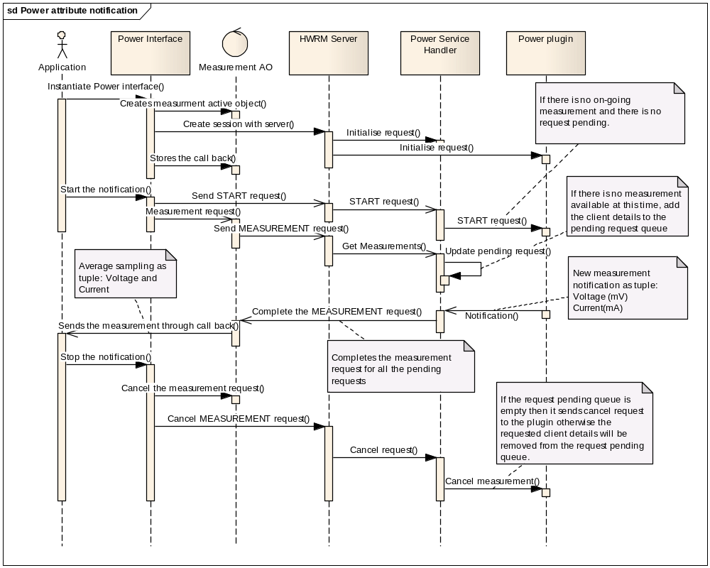
Figure 2.8 Power Attribute notification

Creating a FmTx session

Operation | Creating a power session.  static CHWRMFmTx* NewL(MHWRMFmTxObserver* aCallback = NULL);  static CHWRMFmTx* NewLC(MHWRMFmTxObserver* aCallback = NULL);
Preconditions | HW Resource Manager Server is started.
Description | FmTx session is created for client to interact with FM Transmitter
Inputs | If FM frequency and status indications are desired, callback pointers must be provided.
Modifies | Creates a new client side instance of CHWRMFmTx (actually CHWRMFmTxImpl) and corresponding server side CHWRMSession and CHWRMFmTxService instances.
Outputs | Instance of CHWRMFmTx for client to use or a NULL pointer if creation fails.
Postconditions | FmTx session client side object is ready to be used.
Related To | CHWRMSession  CHWRMFmTxService  CHWRMServer
Exceptions | KErrNotSupported: Device doesn't support FM Tx feature.  KErrNoMemory: if there is a memory allocation failure.

Getting FmTx status

Operation | TFmTxState Status() const;
Preconditions | FmTx client session exists.
Description | FmTx status is returned.
Inputs | None
Modifies | None
Outputs | FmTx status.
Postconditions
Related To | CHWRMSession  CHWRMFmTxStatusObserver
Exceptions

Getting FmTx frequency

Operation | TFmTxState Frequency() const;
Preconditions | FmTx client session exists.
Description | Current FmTx frequency is returned.
Inputs | None
Modifies | None
Outputs | FmTx frequency.
Postconditions
Related To | CHWRMSession  CHWRMFmTxFrequencyObserver  CHWRMFmTxFrequencyObserver
Exceptions | None

Enable the FM Transmitter

Operation | void EnableL(TInt aFrequency=0);
Preconditions | FmTx client session exists.
Description | Enables FmTx.
Inputs | FM frequency.
Modifies | The state of the FmTx is changed EFmTxStateActive or EFmTxStateInactive based on the status of Audio routing (On/Off respectively). If a valid frequency other than 0 is provided the FM frequency is also going to be set to that value.
Outputs | None
Postconditions | FmTx is enabled.
Related To | CHWRMSession  CHWRMFmTxService  CHWRMServer  CHWRMPluginHandler  CHWRMReservationHandler  CHWRMFmTxCommonData  CHWRMFmTxFrequencyObserver
Exceptions | KErrInUse: if reserved by another client.  KErrArgument: if frequency is out of range  KErrNotReady: if there is a wired accessory conflict. Some accessories are mutually exclusive with FM Tx.  KErrNoMemory: if there is a memory allocation failure.  KErrGeneral: if there is a hardware error.

Disable the FM Transmitter

Operation | void DisableL();
Preconditions | FmTx client session exists.
Description | Disables FmTx.
Inputs | None
Modifies | The state of the FmTx is changed to EFmTxStateOff.
Outputs | None
Postconditions | FmTx is disabled.
Related To | CHWRMSession  CHWRMFmTxService  CHWRMServer  CHWRMPluginHandler  CHWRMReservationHandler  CHWRMFmTxCommonData
Exceptions | KErrInUse: if reserved by another client.  KErrGeneral: if there is a hardware error.

Get Frequency Range

Operation | void GetFrequencyRangeL(TFmTxFrequencyRange& aFrequencyRange)
Preconditions | FmTx client session exists.
Description | Queries the valid FM frequency range.
Inputs | None.
Modifies | None.
Outputs | The FM frequency range.
Postconditions | None.
Related To | CHWRMSession  CHWRMFmTxService  CHWRMServer  CHWRMFmTxCommonData  CHWRMFmTxFrequencyObserver
Exceptions | KErrInUse: if reserved by another client.  KErrGeneral: if there is a hardware error.

Set Frequency

Operation | void SetFrequencyL(Tint aFrequency)
Preconditions | FmTx client session exists.
Description | Sets the FM transmission frequency.
Inputs | Frequency.
Modifies | The transmission frequency.
Outputs | None
Postconditions | Transmission frequency has changed.
Related To | CHWRMSession  CHWRMFmTxService  CHWRMServer  CHWRMPluginHandler  CHWRMFmTxCommonData  CHWRMFmTxFrequencyObserver
Exceptions | KErrInUse: if reserved by another client.  KErrArgument: if frequency is out of range  KErrGeneral: if there is a hardware error.

Get the Next Clear Frequency/Frequencies

Operation | void GetNextClearFrequencyL(TInt& aClearFrequency)  void GetNextClearFrequencyL(TClearFrequencyArray& aClearFrequencyArray, TUint& aCount)  void GetNextClearFrequency(TRequestStatus& aStatus, TInt& aClearFrequency)  void GetNextClearFrequencyL(TRequestStatus& aStatus, TClearFrequencyArray& aClearFrequencyArray, TUint& aCount)
Preconditions | FmTx client session exists and transmitter is enabled.
Description | Gets the next clear FM frequency.
Inputs | For the versions that return an array, the number of requested clear frequencies.
Modifies | None
Outputs | Next clear frequency/frequencies
Postconditions | None.
Related To | CHWRMSession  CHWRMFmTxService  CHWRMServer  CHWRMPluginHandler  CHWRMFmTxCommonData
Exceptions | KErrInUse: if reserved by another client  KErrNotSupported: if RSSI scanning is unsupported  KErrGeneral: if there is a hardware error  KErrNotReady: if FM Tx is not enabled  KErrArgument: If aCount is out of range (only for the versions that request an array of frequencies)

Set Transmitter Frequency to the Next Clear Frequency

Operation | void SetNextClearFrequencyL(TInt& aClearFrequency)  void SetNextClearFrequency(TRequestStatus& aStatus, TInt& aClearFrequency)
Preconditions | FmTx client session exists and transmitter is enabled.
Description | Sets the transmission frequency to the next clear FM frequency.
Inputs | None
Modifies | The transmission frequency
Outputs | Next clear frequency.
Postconditions | Transmission frequency is set to the next clear FM frequency.
Related To | CHWRMSession  CHWRMFmTxService  CHWRMServer  CHWRMPluginHandler  CHWRMFmTxCommonData  CHWRMFmTxFrequencyObserver
Exceptions | KErrInUse: if reserved by another client  KErrNotSupported: if RSSI scanning is unsupported  KErrGeneral: if there is a hardware error  KErrNotReady: if FM Tx is not enabled

Enable/Disable Auto-Frequency

Operation | void EnableAutoFrequency()  void DisableAutoFrequency()
Preconditions | FmTx client session exists and transmitter is enabled.
Description | Enables/Disables the FM Tx automatic frequency tuning mode. In this mode, the transmitter will continuously scan for interference from other transmitters. When interference is detected, the FM Tx frequency will change automatically, resulting in a MHWRMFmTxObserver::FmTxFrequencyChanged indication.
Inputs | None
Modifies | The transmission frequency
Outputs | Next clear frequency.
Postconditions | None
Related To | CHWRMSession  CHWRMFmTxService  CHWRMServer  CHWRMPluginHandler  CHWRMFmTxCommonData  CHWRMFmTxFrequencyObserver
Exceptions | KErrInUse: if reserved by another client  KErrGeneral: if there is a hardware error  Apply only to EnableAutoFrequency:  KErrNotSupported: if RSSI scanning is unsupported  KErrNotReady: if FM Tx is not enabled

Get RDS Data

Operation | void GetRdsData(TFmTxRdsData& aData)
Preconditions | FmTx client session exists.
Description | Queries the current RDS data.
Inputs | None
Modifies | None
Outputs | The current RDS data
Postconditions | None
Related To | CHWRMSession  CHWRMFmTxCommonData
Exceptions | None

Set RDS Data

Operation | void SetRdsPtyL(TRdsProgrammeType aPty)  void SetRdsPtynL(TRdsProgrammeTypeName& aPtyn)  void SetRdsMsL(TBool aMusic)  void SetRdsLanguageIdL(TRdsLanguageIdType aLanguageId)
Preconditions | FmTx client session exists and transmitter is enabled.
Description | Sets the RdsProgrammeType/RdsProgrammeTypeName/Music/LanguageId fields of the RDS
Inputs | The data value that the RDS data field is going to be set to.
Modifies | A RDS data field.
Outputs | None
Postconditions | None
Related To | CHWRMSession  CHWRMFmTxService  CHWRMServer  CHWRMPluginHandler  CHWRMFmTxCommonData
Exceptions | KErrInUse: if reserved by another client  KErrGeneral: if there is a hardware error  KErrNotSupported: if RSSI scanning is unsupported  KErrNotReady: if FM Tx is not enabled  KErrArgument: If argument is not valid

Set Radiotext Data

Operation | void SetRadiotextL(TDes& aText)  void SetRadiotextPlusL(TDes& aText, TRtPlusContentType aContentType)  void SetRadiotextPlusL(TDes& aText, TRtPlusTag aTag)  void SetRadiotextPlusL(TDes& aText, TRtPlusTag aTag1, TRtPlusTag aTag2)
Preconditions | FmTx client session exists and transmitter is enabled.
Description | Sets the Text/ContentType/RadiotextPlusTags of the RadioText(Plus).
Inputs | The data value that the Radiotext data field is going to be set to.
Modifies | A Radiotext data field.
Outputs | None
Postconditions | None
Related To | CHWRMSession  CHWRMFmTxService  CHWRMServer  CHWRMPluginHandler  CHWRMFmTxCommonData
Exceptions | KErrInUse: if reserved by another client  KErrGeneral: if there is a hardware error  KErrNotSupported: if RSSI scanning is unsupported  KErrNotReady: if FM Tx is not enabled  KErrArgument: If argument is not valid

Checking the policy

Operation | Check client application’s trust status and priority from policy.  TInt CHWRMPolicy::GetPriority( const RMessagePtr2& aMsg, TBool& aTrusted ) const
Preconditions | Client application wants to reserve resource.
Description | Client application priority and trust is determined. Application is considered trusted if its SID is listed in a policy file (see Section 3.1).
Inputs | aMsg: Message from client, used to obtain SID.  aTrusted: Returns ETrue if client is trusted, i.e. explicitly specified in policy file.
Modifies
Outputs | Priority of the client application.
Postconditions | Client application priority and trust are known.
Related To
Related Event | See Section 2.3.7.
Exceptions

Loading a resource plug-in

Operation | Loading a plug-in.  static CHWRMPluginService* CHWRMPluginService::NewL(const TDesC8& aMatch, MHWRMPluginCallback* aResponseCallback)
Preconditions | HW Resource Manager Server is starting/started.
Description | The light, vibra and power plug-ins are loaded using ECom mechanism. The default_data field of IMPLEMENTATION_INFO in the plug-in resource file identifies correct plug-in implementation. Value HWRMLight identifies light plug-in, HWRMVibra identifies vibra plug-in and HWRMPower identifies power plug-in.
Inputs | aMatch: Determines the API that the loaded plug-in implements.  aResponseCallback: Pointer to plug-in callback handler.
Modifies | Light. vibra or power plug-in library is loaded to memory.
Outputs | Pointer to new CHWRMPluginService instance.
Postconditions | Light, vibra or power plug-in is ready to be used.
Related To | See Section 2.3.1.
Related Event | In case of lights: Startup of HW Resource Manager Server (see Section 2.3.1).  In case of vibra: First vibra client connection to HW Resource Manager Server.
Exceptions | Normal Symbian exceptions.

Loading the target modifier plug-in

Operation | Loading the target modifier plug-in.  static CHWRMTargetModifierPlugin* NewL(const TDesC8& aMatch)
Preconditions | HW Resource Manager Server is starting/started.
Description | The target modifier plug-in is loaded via the ECom mechanism. It is this plug-in module that is responsible for device specific target modification according to target activation status.  The default_data field of IMPLEMENTATION_INFO in the plug-in resource file identifies correct plug-in implementation. Value HWRMLight identifies target modifier plug-in for lights plug-in.
Inputs | aMatch: Determines the resource for which target modifier plug-in is required.  Note that currently only light target modification is supported.
Modifies | Target modifier plug-in is loaded to memory.
Outputs | Pointer to new CHWRMTargetModifierPlugin instance.
Postconditions | Target modifier plug-in has been properly initialized and is ready to use.
Related To | See Section 2.3.1.
Related Event | See Section 2.3.1.
Exceptions | Out of Memory condition.

Loading the power state plug-in

Operation | Loading the power state plug-in.  static CHWRMPowerStatePlugin* NewL( MHWRMPowerStatePluginCallback* aNotificationCallback)
Preconditions | HW Resource Manager Server is starting/started.
Description | The power state plug-in is loaded via the ECom mechanism. It is this plug-in adaptation module that is responsible for notifying the HW Resource Manager Server of any updates to battery level, battery status or charging status of the device.  The default_data field of IMPLEMENTATION_INFO in the plug-in resource file is used to identify the plug-in and must have the value HWRMPowerState.
Inputs | aNotificationCallback: Pointer to plug-in notification callback.
Modifies | Power state plug-in is loaded to memory.
Outputs | Pointer to new CHWRMPowerStatePlugin instance.
Postconditions | Power state plug-in has been properly initialized and is ready to use.
Related To | See Section 2.3.1.
Related Event | See Section 2.3.1.
Exceptions | If the device does not support power state notifications and/or plug-in is not present on the device, operation leaves with the error code KErrNotSupported.  Out of Memory condition.

Publishing power state

Operation | Publishing power state via P&S keys.
Preconditions | Power state plug-in has been properly initialized.
Description | Power state information is updated by notification from the power state plug-in and published via the following P&S keys:  - KHWRMBatteryLevel: Indicates battery level from 0 to 7.  - KHWRMBatteryStatus: Status of battery e.g. Uninitialized, Ok, Low, Empty.  - KHWRMChargingStatus: Status of device related to charging e.g. Charging, Not charging, charging complete etc.  For details of P&S, see Section 3.2.3
Inputs
Modifies | P&S keys detailed above are updated by plug-in.
Outputs | See “Modifies” field above.
Postconditions | All listeners to above P&S keys are notified of the state change.
Related To | See Section 3.2.3.
Related Event | See Section 2.3.32.
Exceptions

Forcibly blocking the vibra

Operation | Forcibly blocking vibra usage.  void CHWRMVibraCommonData::PSValueChanged(const TUid& aUid, TUint32 aKey, TInt aValue)  (Generic P&S value change handler in CHWRMVibraCommonData)
Preconditions | Accessory or charger is connected that cannot operate simultaneously with vibra.
Description | HW Resource Manager is instructed via P&S to block all vibra usage.
Inputs | aUid: Always KPSUidHWResourceBlocking.  aKey: KHWRMAccessoryVibraBlocked or KHWRMInternalVibraBlocked.  aValue: Zero or non-zero.
Modifies | Vibra lock is set if non-zero value is set to the KHWRMAccessoryVibraBlocked property.
Outputs
Postconditions | Vibra is considered locked or unlocked, depending on the KHWRMAccessoryVibraBlocked and KHWRMInternalVibraBlocked values.
Related To | P&S (see Section 3.2.3).
Related Event | Accessory Server sets KHWRMAccessoryVibraBlocked property value.  HWRM Power State Plug-in sets KHWRMInternalVibraBlocked property value.
Exceptions

Backup and Restore
This component does not participate in Backup and Restore.

System resource usage

Files
See reference document R2 for policy file specifications.
HW Resource Manager also indirectly needs several Central Repository initialization files that should be provided by platform. See Section 3.2.2 for details.

Other data

Databases
This component does not use any databases.

Central Repository
This component uses Central Repository. See R3 for more details.

Publish and Subscribe
This component uses Publish and Subscribe.

Memory consumption
HW Resource Manager consists of 6 binaries: HWRMServer.exe, HWRMLightClient.dll, HWRMExtendedLightClient.dll, HWRMVibraClient.dll, HWRMPowerClient.dll, HWRMFmTxClient.dll, HWRMClient.dll and HWRMCommon.dll. Their combined memory consumption is given in table below.
Memory/Build | Consumption
User data area | <1 KB for files specified in Section 3.1.
WINSCW UDeb | ~950 KB – Does not include plug-ins.
ARMV5 URel | ~26 KB – Does not include plug-ins.

Task allocation
HW Resource Manager Server runs in its own process, which is started by Starter component.

Performance
HW Resource Manager light and vibra commands are synchronous, which may not be fast enough for games and some other applications. In future it might be necessary to create asynchronous versions of control methods.
The battery commands are asynchronous apart from EHWRMStopAverageBatteryPowerReporting command which is synchronous.
The FM Transmitter commands are synchronous except GetNextClearFrequency and SetNextClearFrequency that are asynchronous and GetNextClearFrequencyL which has both asynchronous and synchronous.

Timers

Timer | Purpose | Interval | Lifetime
Vibra call timer | Stop vibra after specified duration. | Variable | Active only during duration based calls. Each vibra session has one timer.
Light call timer | Restore lights base state after specified duration. | Variable | Active only during duration based calls. Each light session has up to 4 timers.
Voltage Measurements Timer | Cut off time for voltage measurements reporting | Cen Rep Configurable | Active during the life time of a Start voltage request
Consumption Measurements Timer | Cut off time for consumption measurements reporting | Cen Rep Configurable | Active during the life time of a Start consumption request
Power Measurements Timer | Cut off time for power measurements(Voltage and current together) reporting | Cen Rep configurable | Active during the life time of a Start power measurement request
FmTx Power Save Timer | FM Transmitter timer is disabled after specified duration inactivity | Cen Rep Configurable | Active after Audio Routing is set to off while transmitter is enabled.
Plug-in handler timer | Cancel plug-in call if it timeouts. | Configurable; typically 30 seconds. | Active only when plug-in calls are active.

Security

Capabilities of this component
HW Resource Manager Client DLLs of this component have capability set of All -TCB.
HW Resource Manager Server has capability set of ReadDeviceData WriteDeviceData ProtServ CommDD.

Input and output validation
Client APIs validate that all parameters contain acceptable values for fastest possible response time. Server validates the values passed to it by the client, in case the client is a malicious one.

Environmental assumptions
HW Resource Manager Server assumes that Z-drive is the ROM drive.

Additional enforcements
P&S keys used to pass lights and vibra status to clients. KHWRMVibraStatus, KHWRMLightStatus and KHWRMFmTxStatus are defined with SID restriction, so only HW Resource Manager can set them.
Vibra locking P&S keys (KHWRMAccessoryVibraBlocked and KHWRMInternalVibraBlocked) are protected with WriteDeviceData capability.
ReadDeviceData and WriteDeviceData capabilities restrict HW Resource Manager Central Repository keys usage.

Exception handling
All exceptions are propagated to clients to handle, if they occur during a client call. Timer or event initiated call exceptions are Trapped and ignored. For more details about exceptions, see Section 2.3.
If HW Resource Manager Server process panics or exits for any reason, system reboots. HW Resource Manager Server only panics when it encounters an unrecoverable error condition.
HW Resource Manager Server panics the client if it sends unsupported command with SendReceive.

Usage

User's guide
Initializing and uninitializing
To create light, vibra, power or FmTx client session, instantiate CHWRMLight, CHWRMVibra, CHWRMPower or CHWRMFmTx object with one of the supplied factory methods.
For example:
#include <HWRMVibra.h> // link against HWRMVibraClient.lib
. . .
CHWRMVibra* vibra = CHWRMVibra::NewL(); // No callbacks

To clean up, simply delete the created object:
delete vibra;

Basic usage
Basic use of vibra, lights, power, FMTx is simple: Just call the required methods.
For example:
vibra->StartVibraL(5000); // Start vibra for five seconds
. . .
vibra->StopVibraL(); // Immediately stop vibra

Callbacks
To enable callbacks, you need a callback object that inherits from correct observer and implements the callback methods.
A callback object header example:
class CTests : public CBase,
public MHWRMVibraObserver,
public MHWRMLightObserver
{
public:
CTests();
~CTests();

void ConstructL();
static CTests* NewL();

// from MHWRMVibraObserver
virtual void VibraModeChanged(CHWRMVibra::TVibraModeState aStatus);
virtual void VibraStatusChanged(CHWRMVibra::TVibraStatus aStatus);

// from MHWRMLightObserver
virtual void LightStatusChanged(TInt aTarget,
CHWRMLight::TLightStatus aStatus);

private:
CHWRMVibra* iVibra;
CHWRMLight* iLight;
};

A callback method implementation example:
void CTests::LightStatusChanged(TInt aTarget,
CHWRMLight::TLightStatus aStatus)
{
RDebug::Print(_L("### Light state changed for target: 0x%x"), aTarget);
switch ( aStatus )
{
case CHWRMLight::ELightOn:
RDebug::Print(_L("### Light state changed: ELightOn"));
break;
case CHWRMLight::ELightOff:
RDebug::Print(_L("### Light state changed: ELightOff"));
break;
case CHWRMLight::ELightBlink:
RDebug::Print(_L("### Light state changed: ELightBlink"));
break;
case CHWRMLight::ELightStatusUnknown:
RDebug::Print(_L("### Light state changed: ELightStatusUnknown"));
break;
default:
RDebug::Print(_L("### Light state changed: UNDEFINED !"));
break;
}
}

Basic use of Power API:
include <HWRMPower.h> // link against HWRMPowerClient.lib
HWRMPower* power = CHWRMPower::NewL(this, this);

// Get battery info.
TRequestStatus& status;
TBatteryConsumptionData batteryConsumptionData;
power->GetBatteryInfo(status, batteryConsumptionData);

User::WaitForRequest(status);
User::LeaveIfError(status.Int());

To clean up, simply delete the created object:
delete power;

Power consumption(Voltage&Current) Notification

Creating the power object
The HWRM Power object must be instantiated using NewL() or NewLC() methods as given below. There is no call-back pointer required at this time.
#include <HWRMPower.h>

// Instantiate power object
CHWRMPower* power = CHWRMPower::NewL();

Registering the call-back
If the client application requires periodical measurements of power attributes from HWRM server then it needs to derive a class from the interface MHWRMBatteryPowerObserver and implement PowerMeasurement() method as given in the below example:
#include <HWRMPower.h> // Link against HWRMPowerClient.lib

class CTest : public CBase,
public MHWRMBatteryPowerObserver
{
public:
CTest();
~CTest();

void ConstructL();
static CTest* NewL();

// from MHWRMBatteryPowerObserver
virtual void PowerMeasurement( Tint aErrCode,
CHWRMPower::TBatteryPowerMeasurementData& aMeasurement);
private:
CHWRMPower* iPower;
};

This needs to be registered with the HWRM server by calling the API SetPowerReportObserver().
CTest* notifier = CTest::NewL();

// Instantiate power object
CHWRMPower * power = CHWRMPower::NewL();

// Register only for charging status
power->SetPowerReportObserver(notifier);

Power consumption attribute notification request
Client application can request for the power consumption attribute notification using StartAveragePowerReporting() API and cancel the same using StopAveragePowerReportingL(). HWRM server services it by calling the registered call-back with appropriate attribute values along with error code if any.
The StartAveragePowerReporting() is an asynchronous API which takes an parameter of TUint type to mention the sampling interval multiple which is a multiple factor of base-time-interval set(in terms of milliseconds) during the initialisation of HWRM server.
const TInt KSampleIntervalMultiple = 5;
TRequestStatus status(KErrNone);

// Start the power consumption attribute notification
power->StartAveragePowerReporting(status, KSampleIntervalMultiple);
User::LeaveIfError( status );
...
// Cancel the notification
Power->StopAveragePowerReportingL();

Error handling
The asynchronous start API returns the status as KErrNone if the request is successfully submitted to the power adaptation plug-in by the HWRM server. Otherwise, it returns KErrNotSupported if the feature is not supported by the power adaptation or any system wide error code.
Once the start request is successful then the HWRM sends the notification of the power attributes through the registered call-back. The type of the measurement will be CHWRMPower::TBatteryPowerMeasurementData which contains the Voltage(mV) and Current(mA) data. Following error code will also be passed through the call-back if there is any.
KErrNotSupported | If the power adaptation plug-in is failed to load or not present on the device.
KErrAlreadyExists | If the application sends the start request more than once, HWRM server will not process the second one.
KErrBadHandle | If the notification API is called without registering the call back.

Further Information

References
No. | Document Reference | Version | Description
[R1] | How-to Write Light, Vibra, Power and FmTx HWRM Plugin.doc
[R2] | HWRM Policy Configuration.doc
[R3] | HWRM Central Repository keys.xls

Open Issues
None.

Glossary
Term | Definition
API | Application Programming Interface
CenRep | Central Repository
DLL | Dynamic Link Library
FmTx | FM Transmitter
HW | Hardware
HWRM | Hardware Resource Manager
KEF | Key Event Framework
OS | Operating System
P&S | Publish & Subscribe
SID | Security ID
Bitwise-or | The process of OR’ing multiple targets  (EPrimaryDisplay | ESecondaryDisplay).
ECom | Epoc component object model - Symbian provided mechanism for loading plug-in DLLs.
Central Repository | Symbian provided service for storing data centrally.
Publish & Subscribe | Symbian provided service for publishing data runtime.
Resource | In HWRM context, resource (HW resource) is a concrete HW feature that needs controlled access to by multiple clients. Device vibra and lights are such resources.
ROM-only-resolver | An ECom plug-in resolver that makes sure that the plug-in is always loaded from ROM.
Sub-resource | Sub-resource is a logical subpart of a HW resource. E.g. lights resource has primary display and primary keyboard sub-resources, in addition to others.
SysAp | System Application, which is responsible for system lights handling among other things.
System Target | A device specific set of lights targets that are controlled by e.g. user activity. Typically this includes displays and keyboards and excludes custom targets such as LEDs or flashlights.
Target | Another name for sub-resource.

